# Loan Application Status Prediction

## Introduction

In this article we are going to see about constructing a machine learning model for “Loan Approval Prediction”. This machine learning project we will be doing on python. We will perform the analysis step by step and predict the loan will be approved or not based on some given attributes.

When we need extra money for family and personal emergencies such as a wedding or hospitalisation, you might decide to go for a loan. loans are a convenient way of getting additional funding because they require fewer documents and are processed faster than any other retail loan.

The company wants to automate the loan eligibility process (real-time) based on customer detail provided while filling out online application forms. These details are Gender, Marital Status, Education, number of Dependents, Income, Loan Amount, Credit History, and others.

**STEP 1:  PROBLEM DEFINITION**

A loan application is used by borrowers to apply for a loan. Through the loan application, borrowers reveal key details about their finances to the lender. The loan application is crucial to determining whether the lender will grant the request for funds or credit.

Dataset includes details of applicants who have applied for loan. The dataset includes details like credit history, loan amount, their income, dependents etc.

Will build a model that can predict whether the loan of the applicant will be approved or not on the basis of the details provided in the dataset.

* Loan_ID--------------> Unique Loan ID.
* Gender --------------> Male/ Female
* Married --------------> Applicant married (Y/N)
* Dependents ------------> Number of dependents
* Education -------------> Applicant Education (Graduate/ Under Graduate)
* Self_Employed ---------> Self-employed (Y/N)
* ApplicantIncome -------> Applicant income
* CoapplicantIncome -----> Coapplicant income
* LoanAmount -----------> Loan amount in thousands
* Loan_Amount_Term ------> Term of a loan in months
* Credit_History --------> Credit history meets guidelines
* Property_Area ---------> Urban/ Semi-Urban/ Rural
* Loan_Status -----------> Loan approved (Y/N)

You have to build a model that can predict whether the loan of the applicant will be approved or not on the basis of the details provided in the dataset.

**STEP 2: DATA ANALYSIS**

In this data set we are provided with **Loan Status of loan a**pproved or not. We are provided with the data set with 614 rows and 12 columns. You can find the data set in GitHub. First, we need to import all the libraries needed then we need to import the data set.

Loan Status which is a binary variable that takes the values Yes(Y)/No(N) serves as the Target Variable which needs to be predicted utilizing the test data.

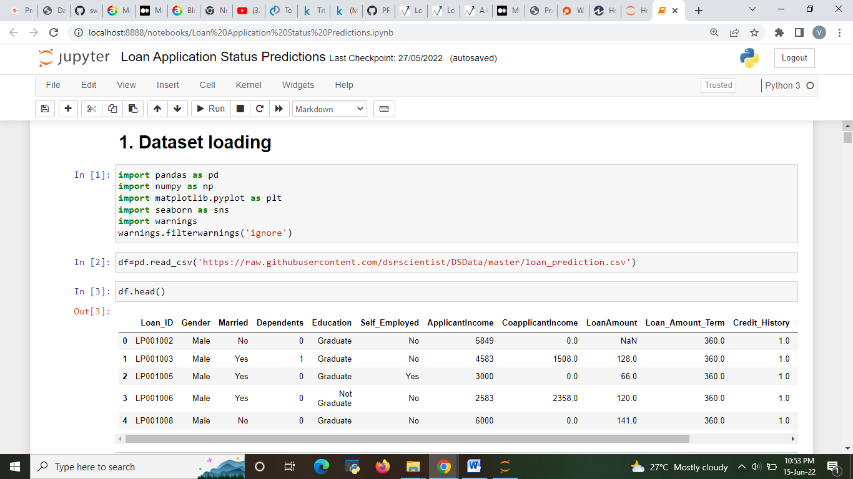

Fig1 – imported the required libraries and imported data set.

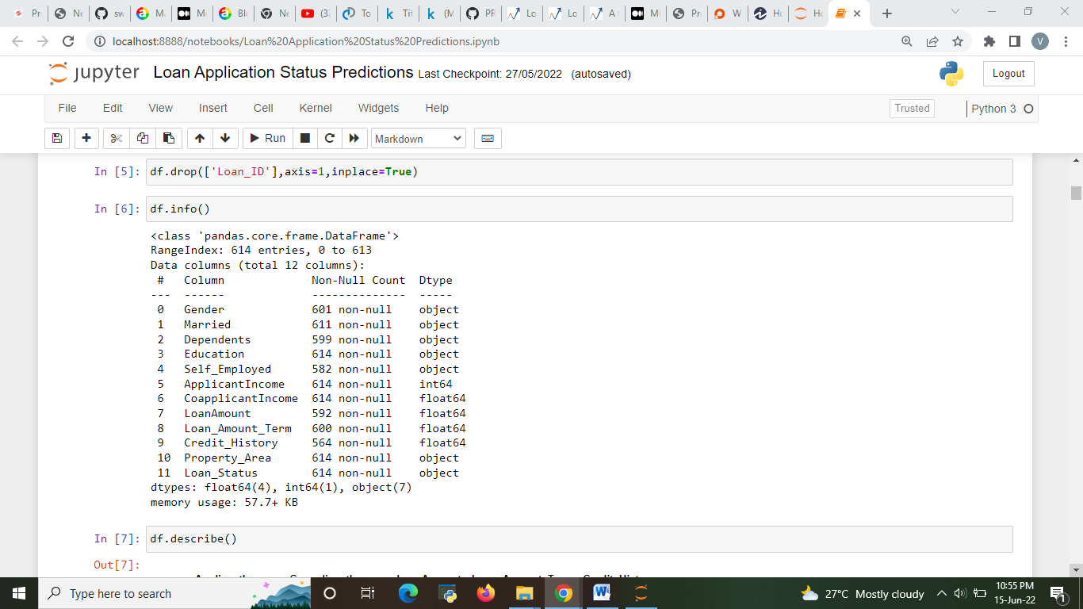

Fig 2 – Information about the attributes and dropping the unwanted column in the data set.

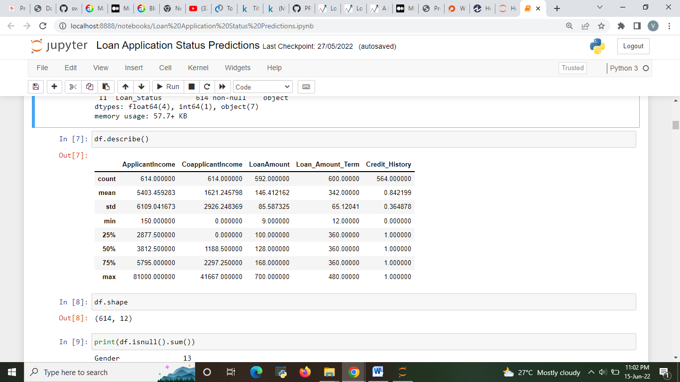

Fig3- Checking shape of the data and Statistical data analysis of dataset.

* So we have 614 rows and 12 columns in our training dataset.

**STEP 3: EDA CONCLUDING REMARKS**

First we need to do the pre processing and examine the data need to find the shape of the data and check for any null values present in the data.

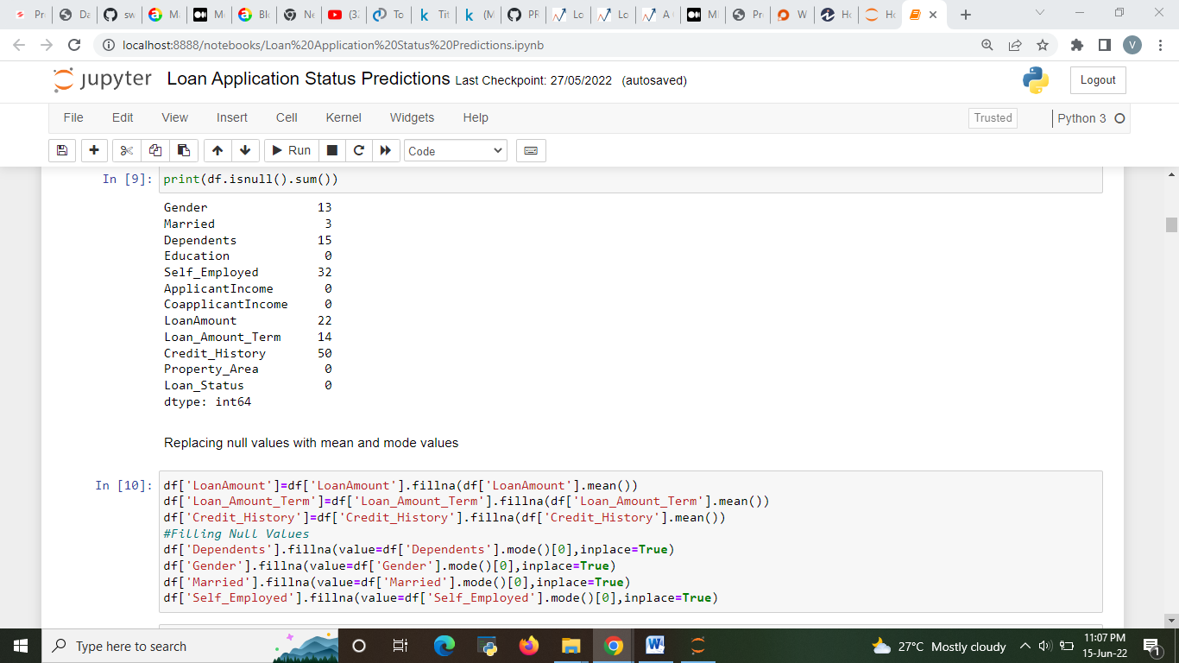

Fig3- Checking the null value. Replace the null values present in the data.

There is another method to remove null value. If your data had more null values then you need to replace it with the mean, median mode vales. There is a simple thing you need to understand before replacing your null values,

* Replace with **mode** value when your data is categorical.
* Replace with **mean** value if data is numeric and normally distributed.
* Replace with **median** value if data is numeric and not normally distributed.

After this step you can do visualization technique as per your creativity. **Visuals transform the data into illustrations that help uncover insights**. You can explore data as per your need use multiple plots, different visualization technique. You also need to perform Univariant, Bivariant and multivariant analysis. I will show you few examples how you can use plots.

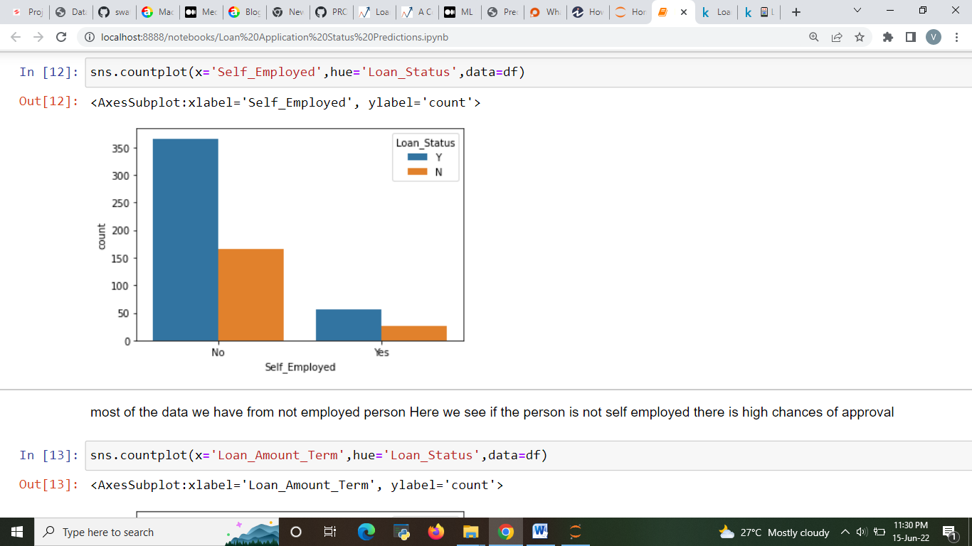

Fig 6: example of visualization

* From this plot you can understand about various not employed person Here we see if the person is not self employed there is high chances of approval.
* Count of self-employed is less than that of Non-Self-employed.

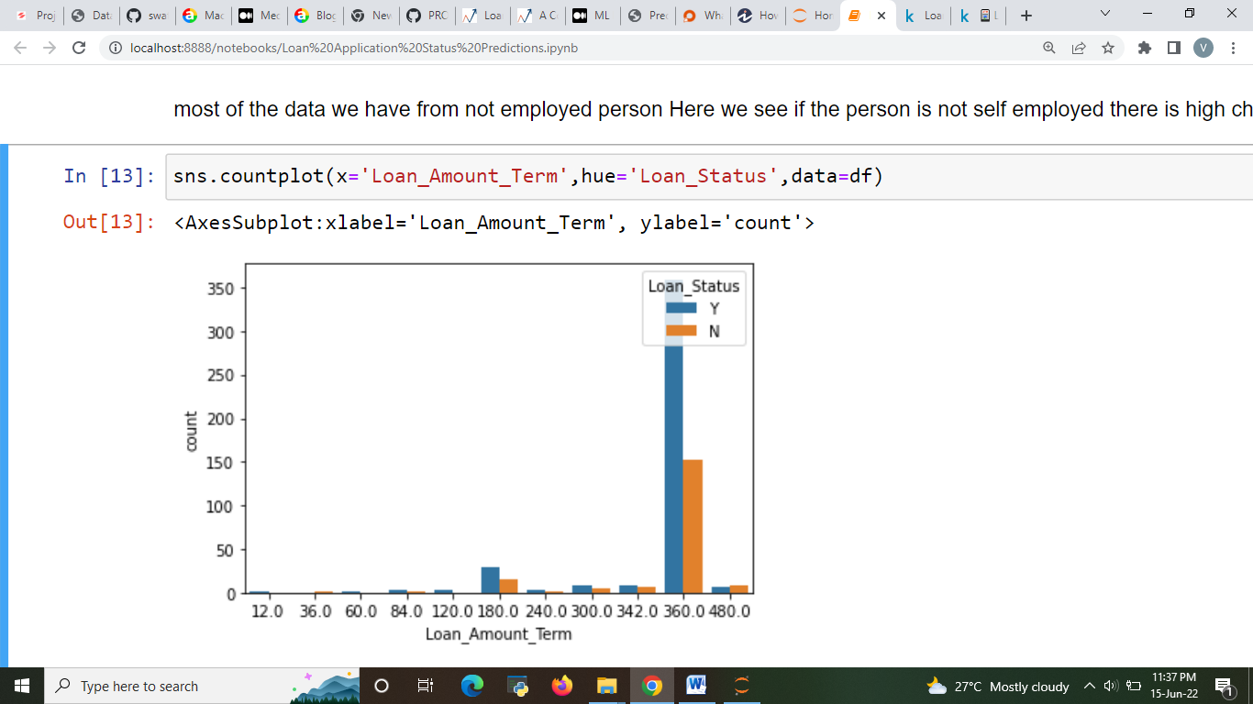

Fig 7: Loan_Amount_Term

Most of the people who applied for loan asked for 360 months of term more half are getting approved People those are taking loan for 480 months, most of them are getting approval

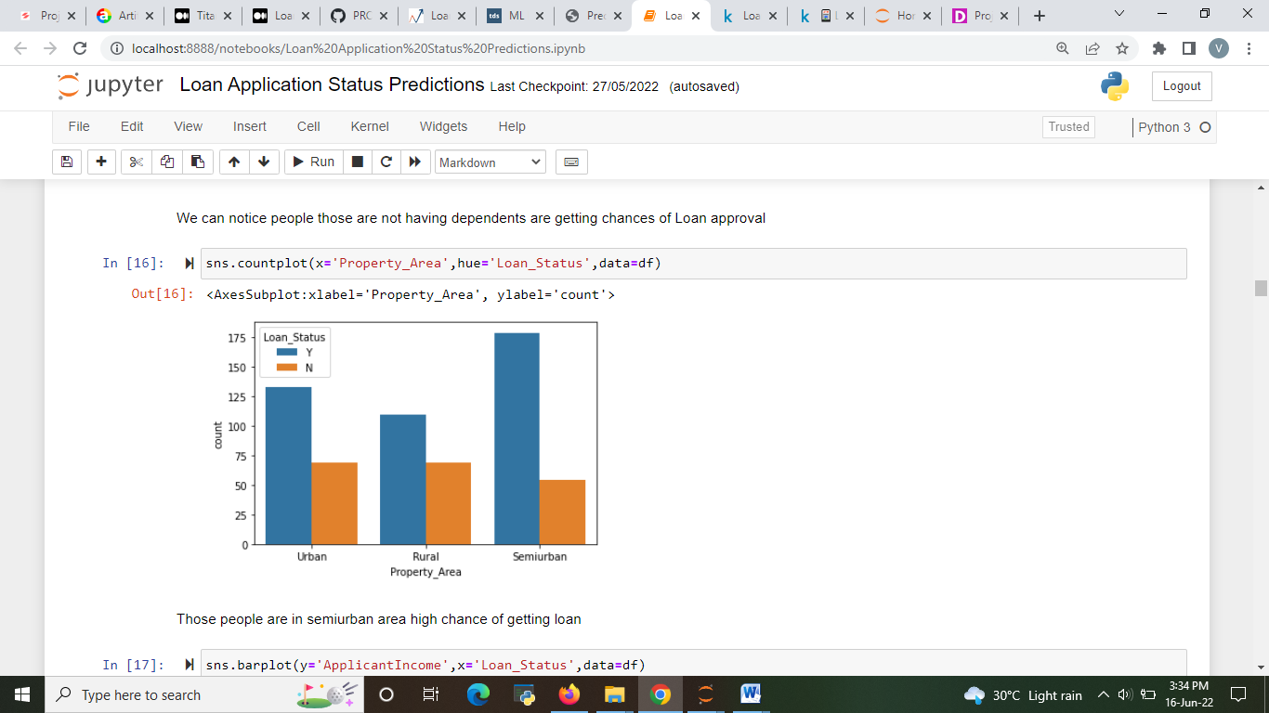

Fig 8- property area

* Those people are in semiurban area high chance of getting loan when compare with the Urban and Rural area.
* Maximum properties are located in Semi urban areas

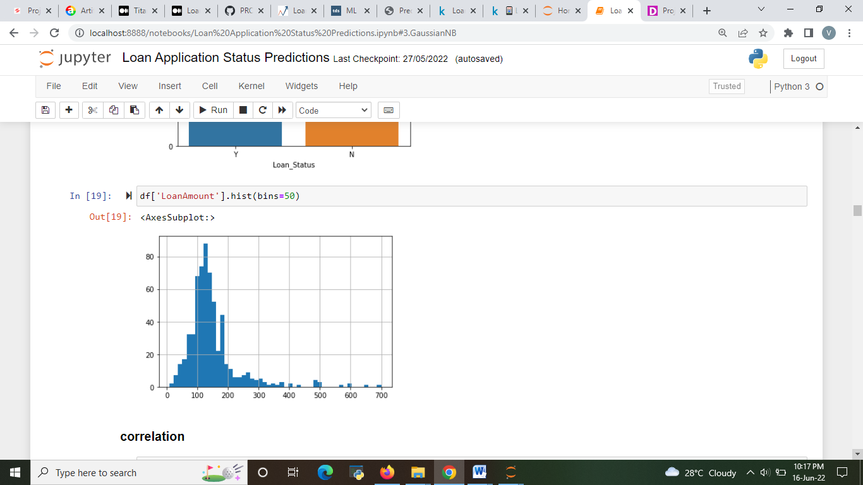

Fig 9- Loan amount

* **Correlation**

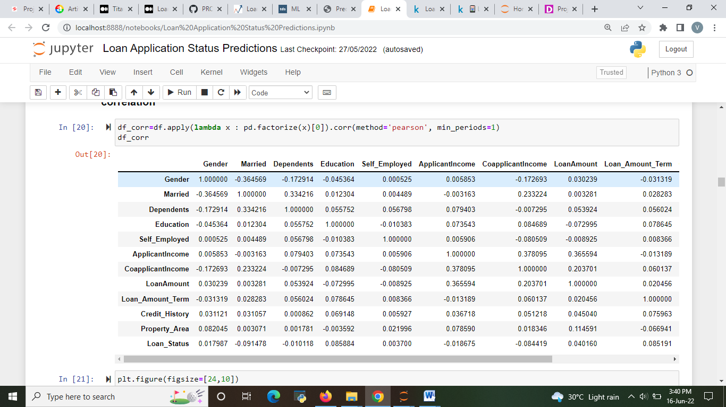

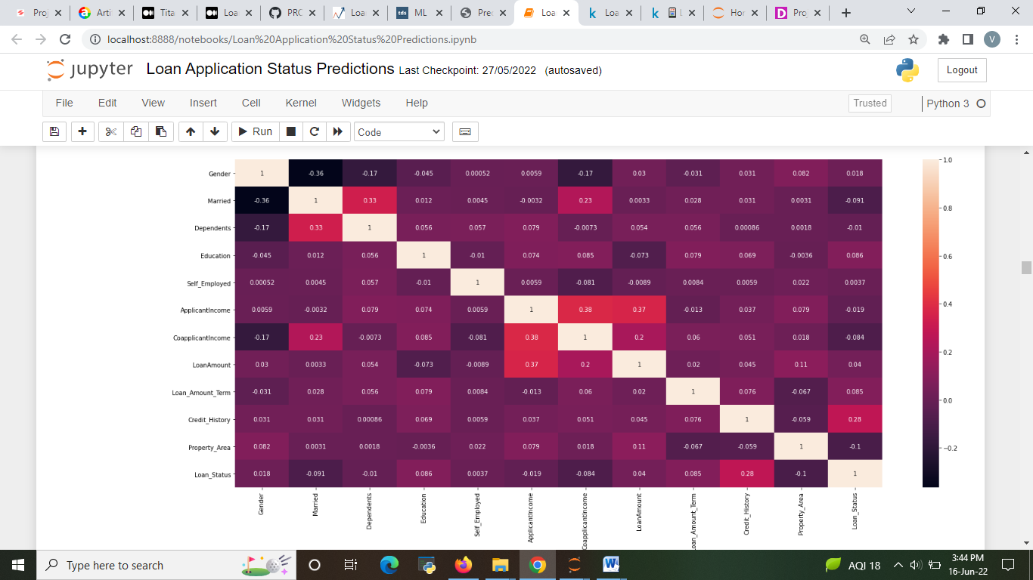

* **Check the distribution of data**

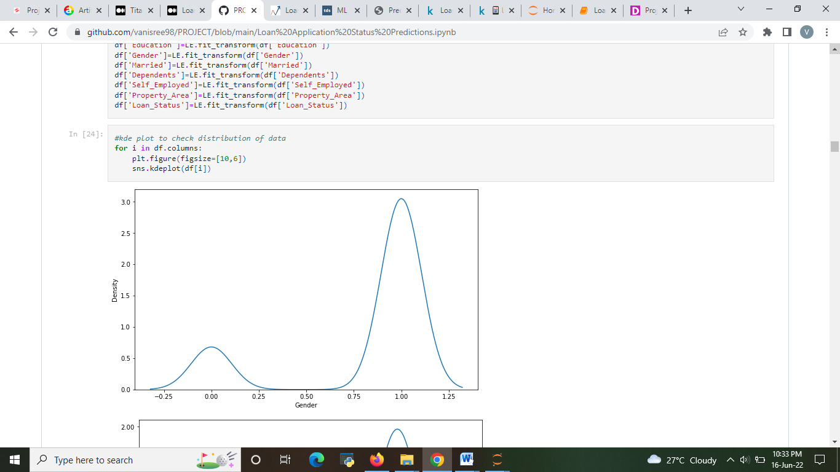

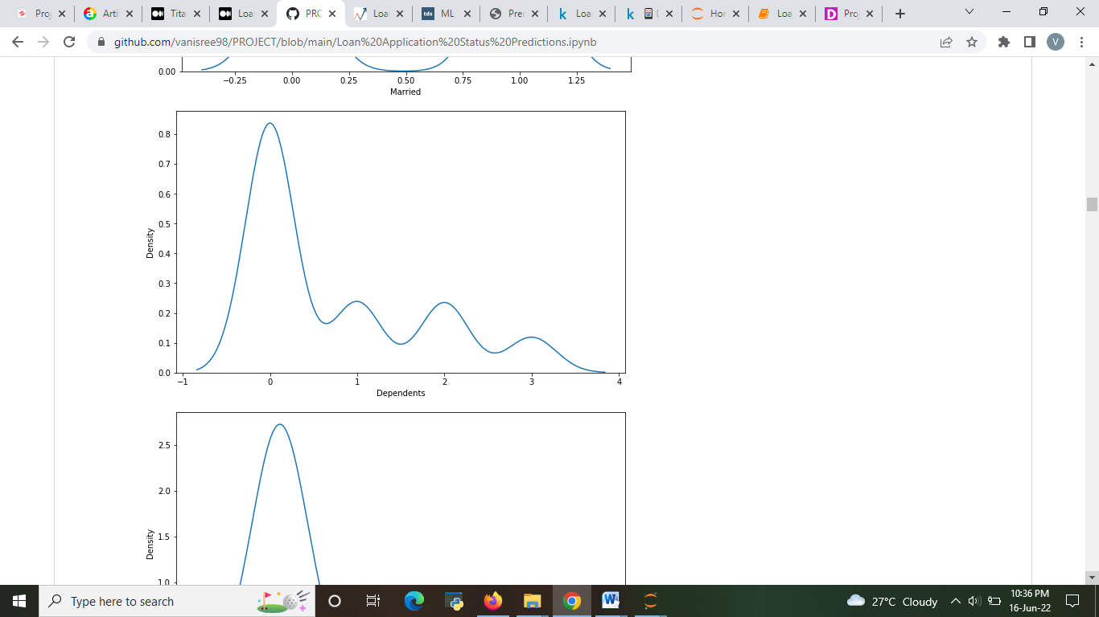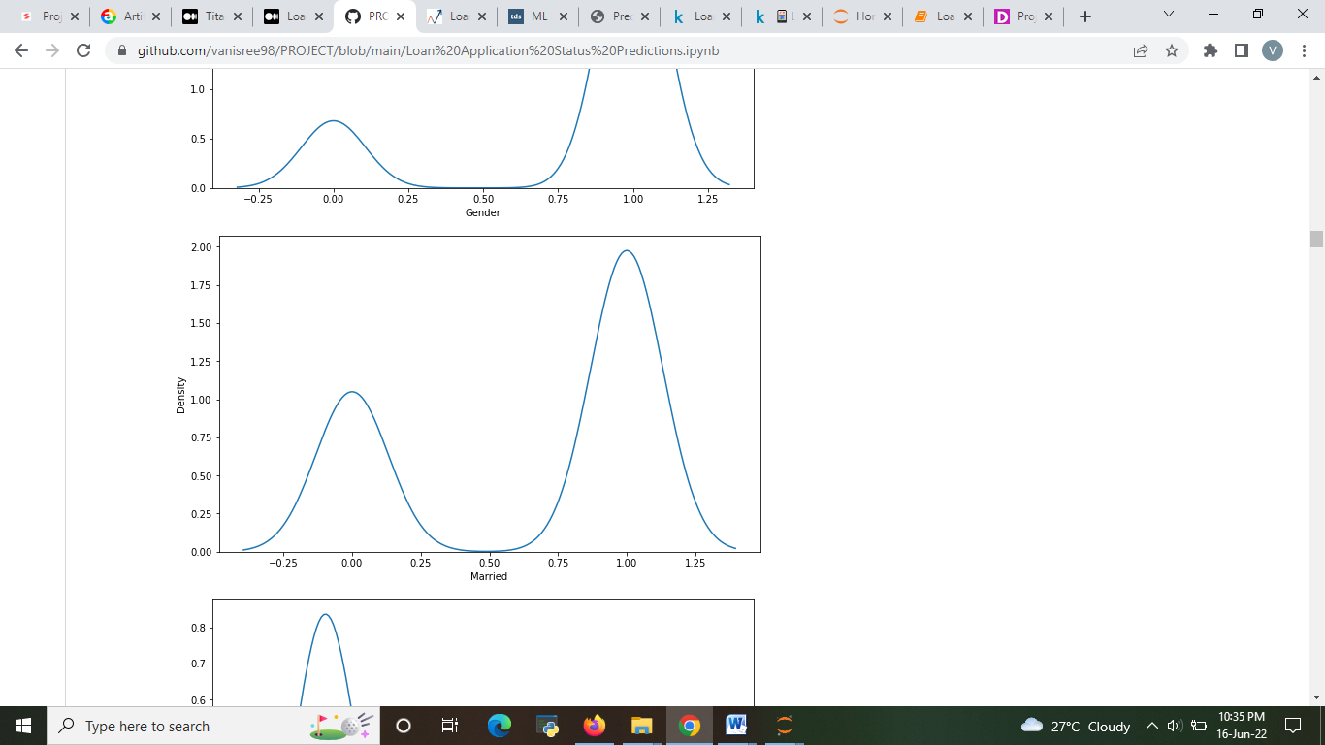

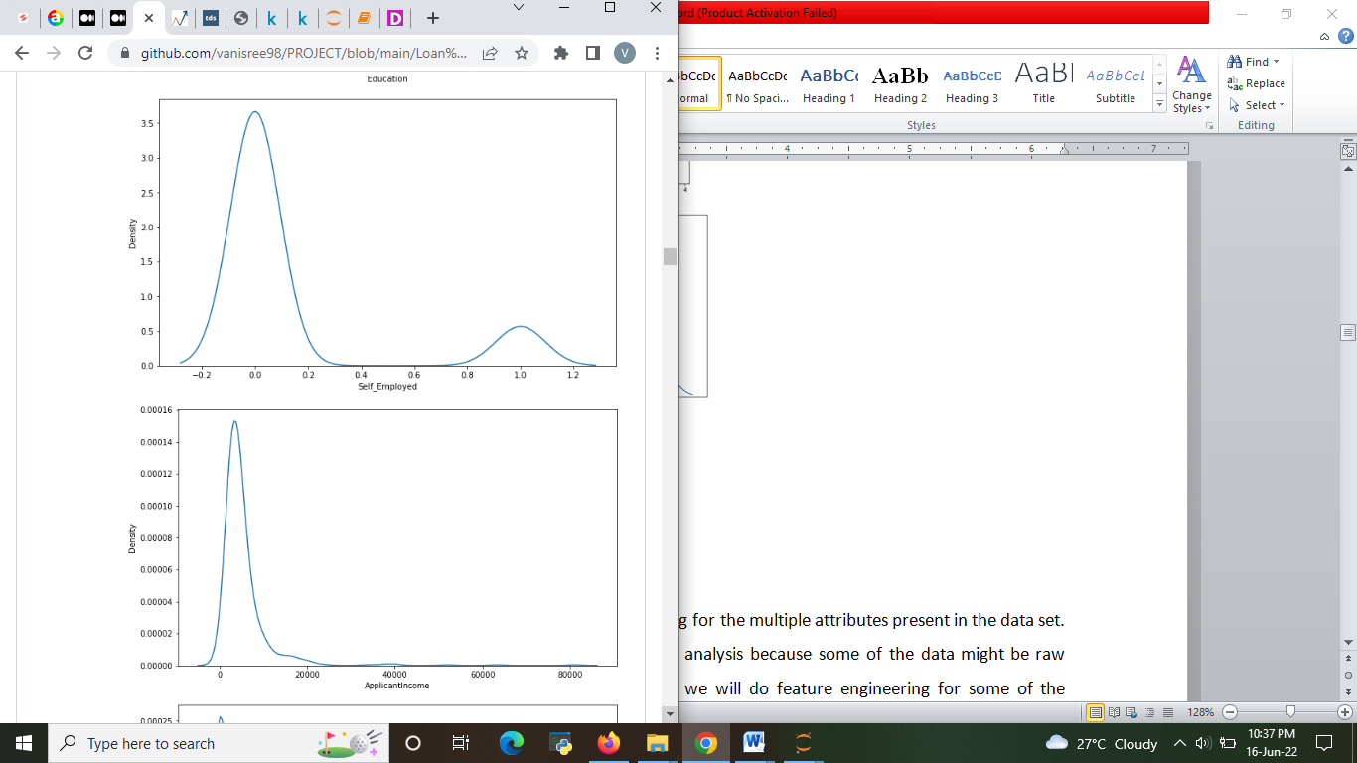

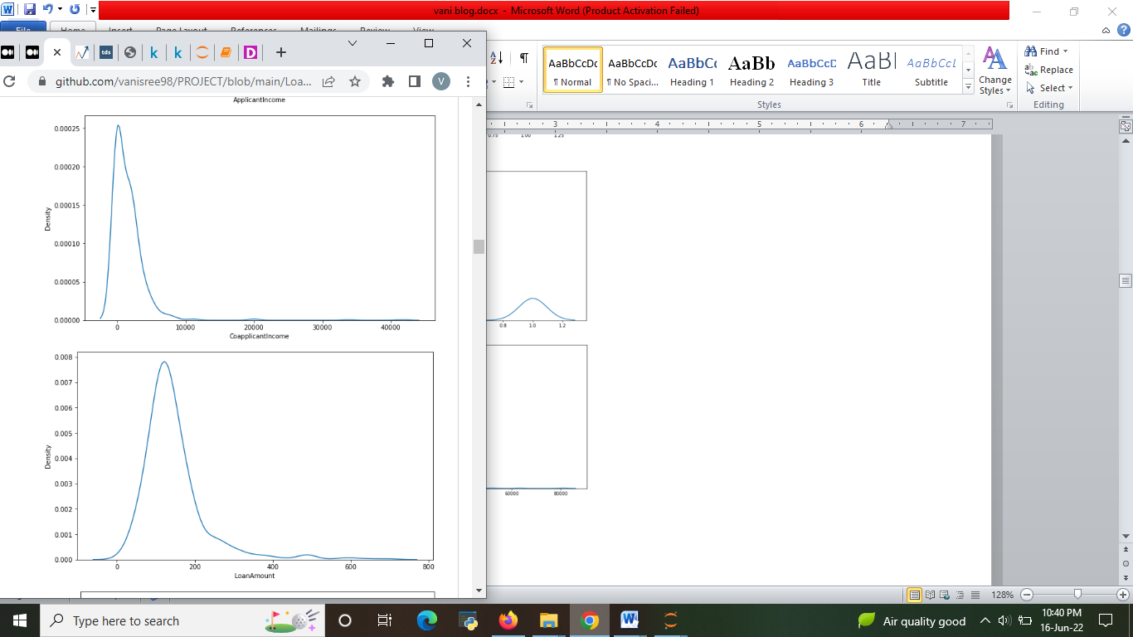

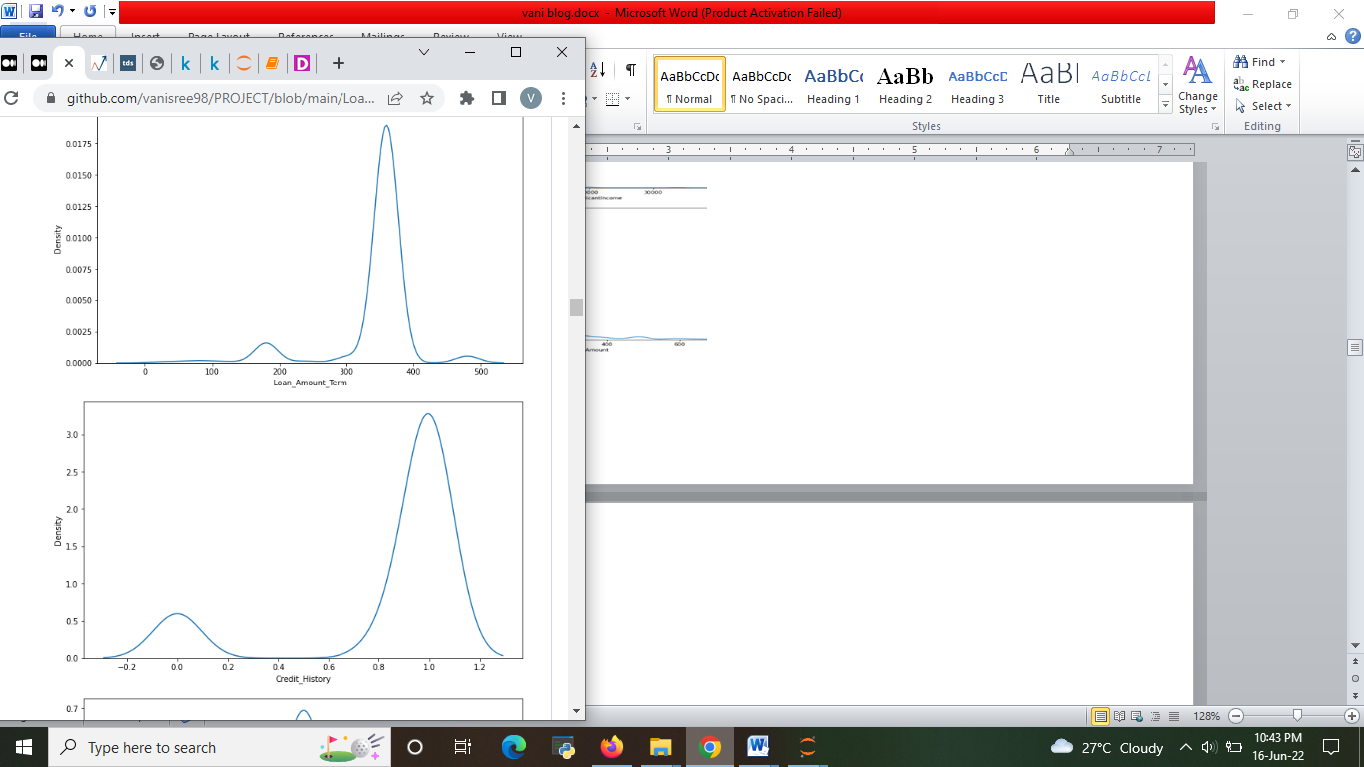

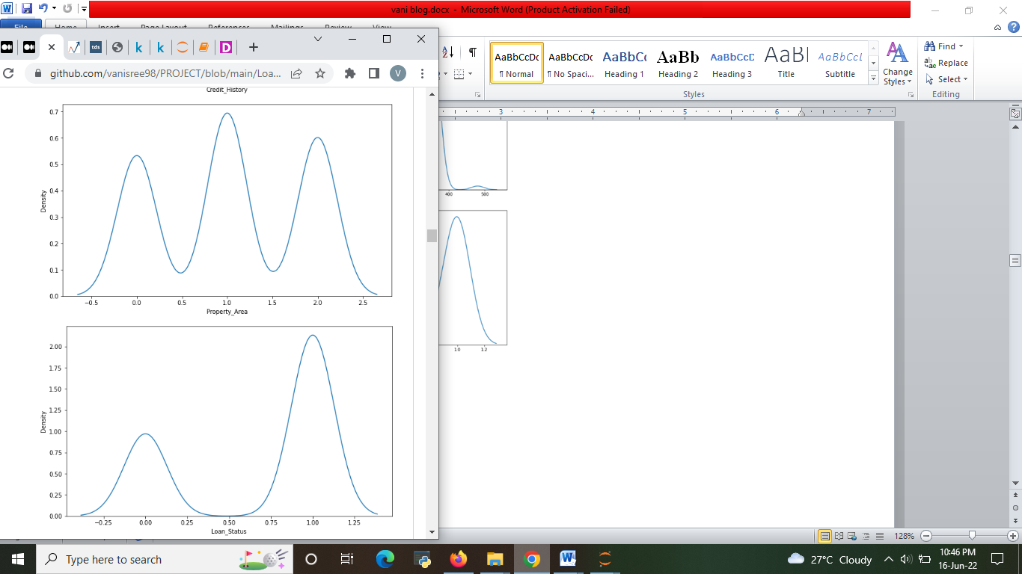

* ApplicantIncome Overfitting is not muchpresent.
* CoapplicantIncome Overfitting is Present
* **Check the outliers**

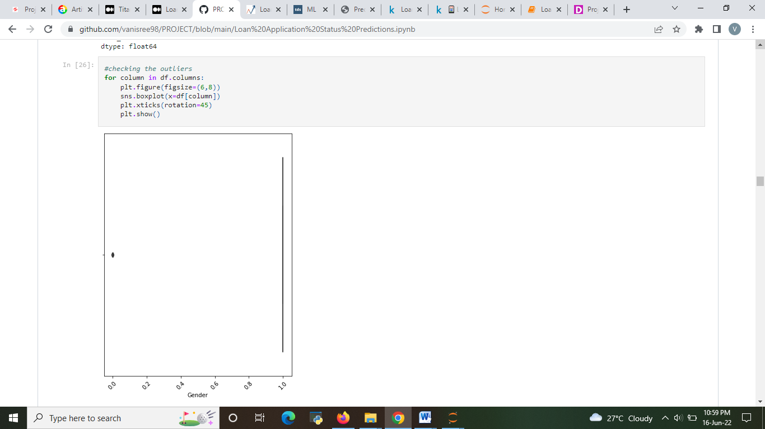

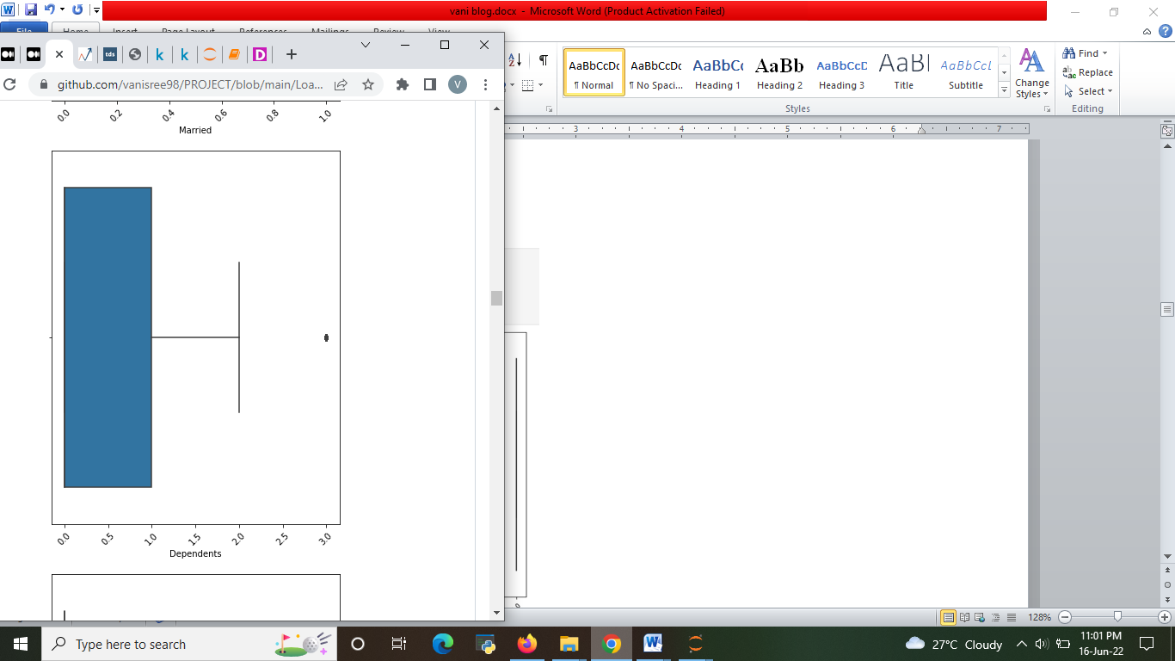

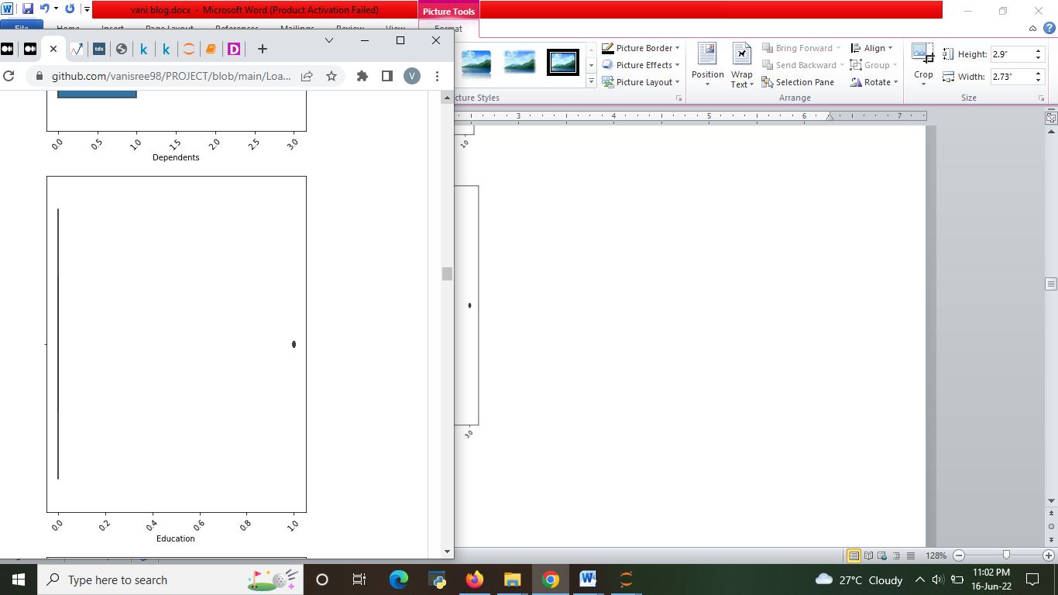

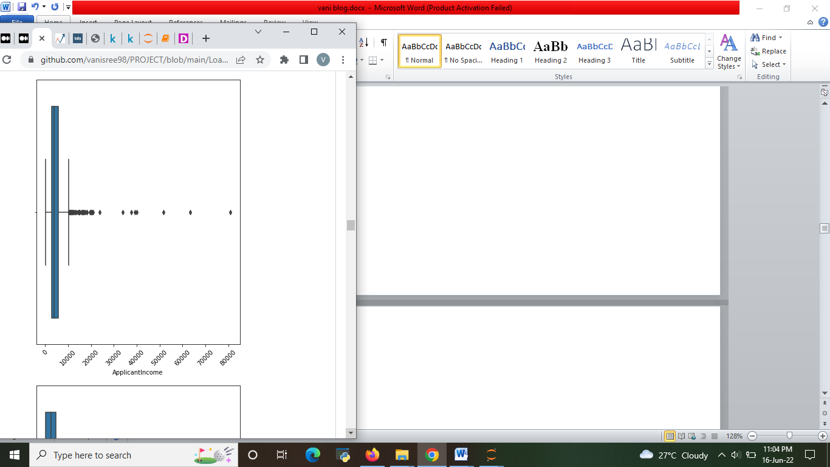

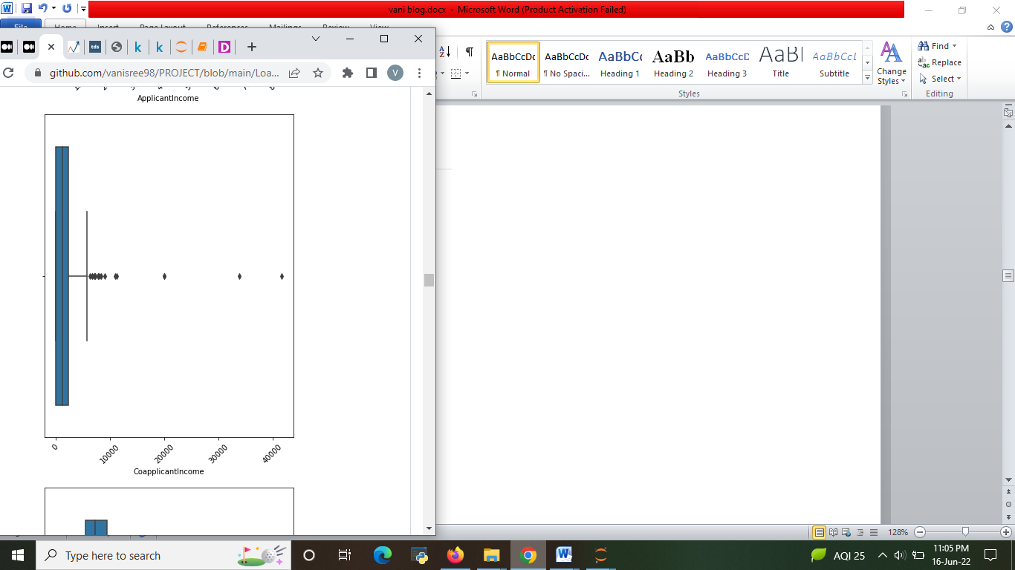

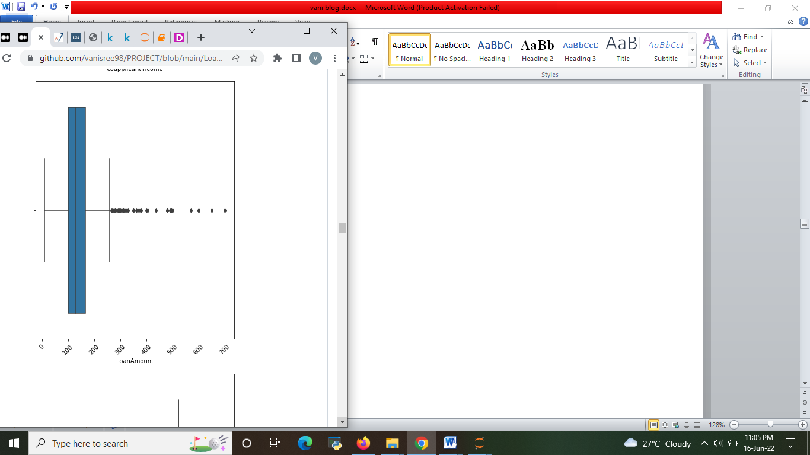

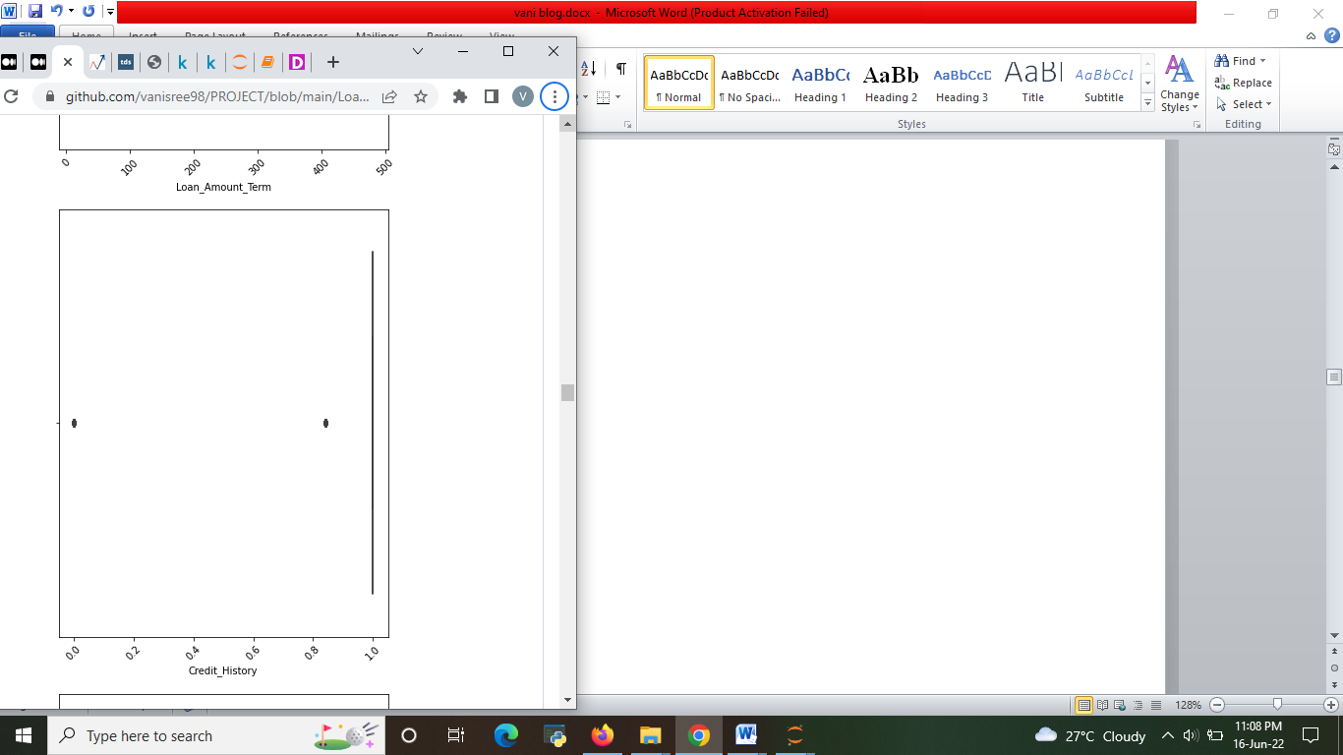

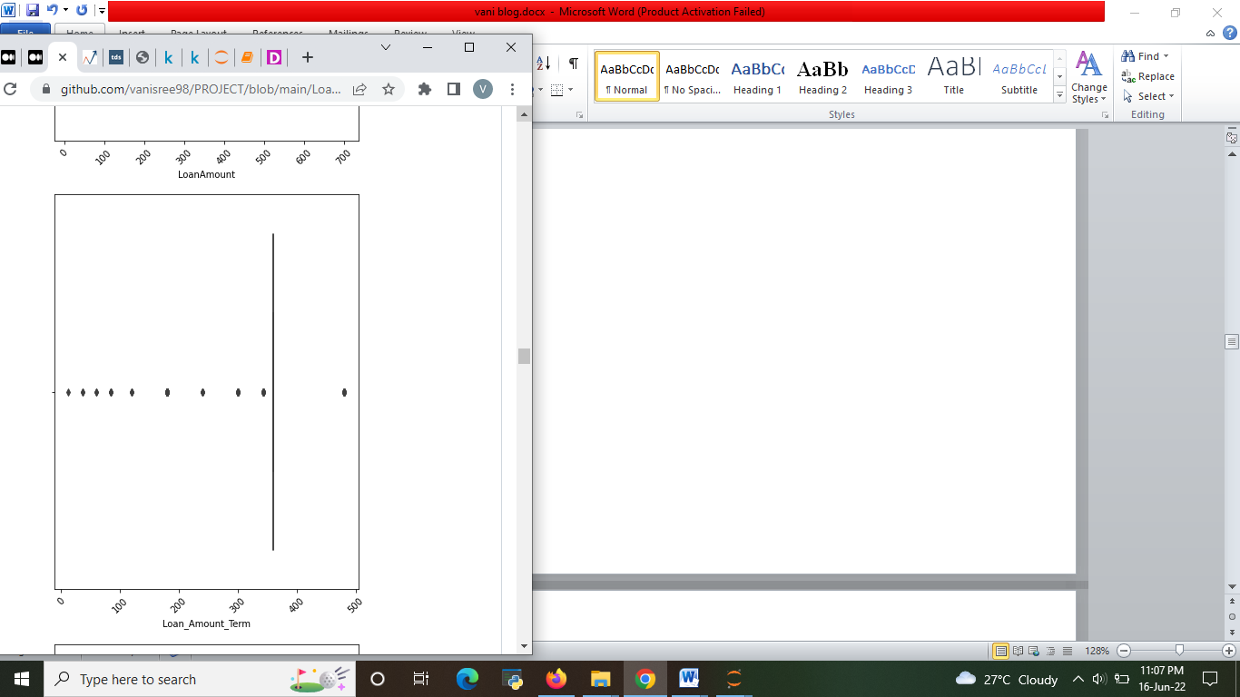

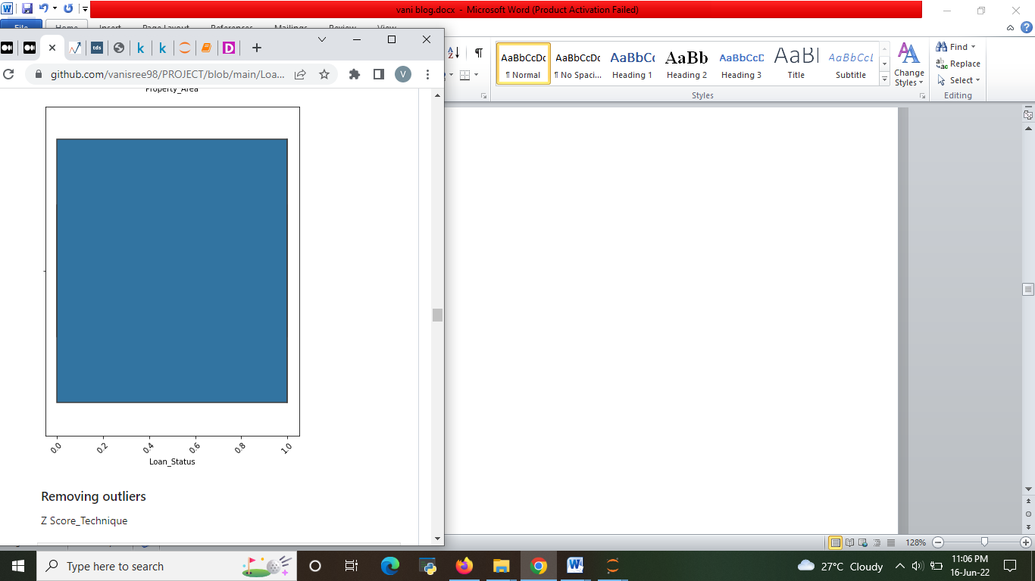

* ApplicantIncome, CoapplicantIncome, Loan_Amount_Term, Credit_History, Self_Employed,

And LoanAmount are have outliers.so we have remove outliers .To predict the model accuratly

**STEP 4: PRE-PROCESSING PIPELINE**

Now we need to perform Feature engineering for the multiple attributes present in the data set. It is very important step to be done before analysis because some of the data might be raw which are not applicable for analysis. Now we will do feature engineering for some of the attributes present in the data.

We also need to check the skewness of the data before constructing the model. Having outlier might be a reason for skewness. In that case outlier must be removed. You can find outliers in the data by plotting box plot.

* Outliers removing techniques
* IQR
* Z score
* Then skewness need to be treated using various techniques like
* square root transformation
* cube root transformation
* Log Transform
* Box-Cox Transform

#### Removing skewness

#### 

#### Fig: Square root of dataset

#### Removing outliers

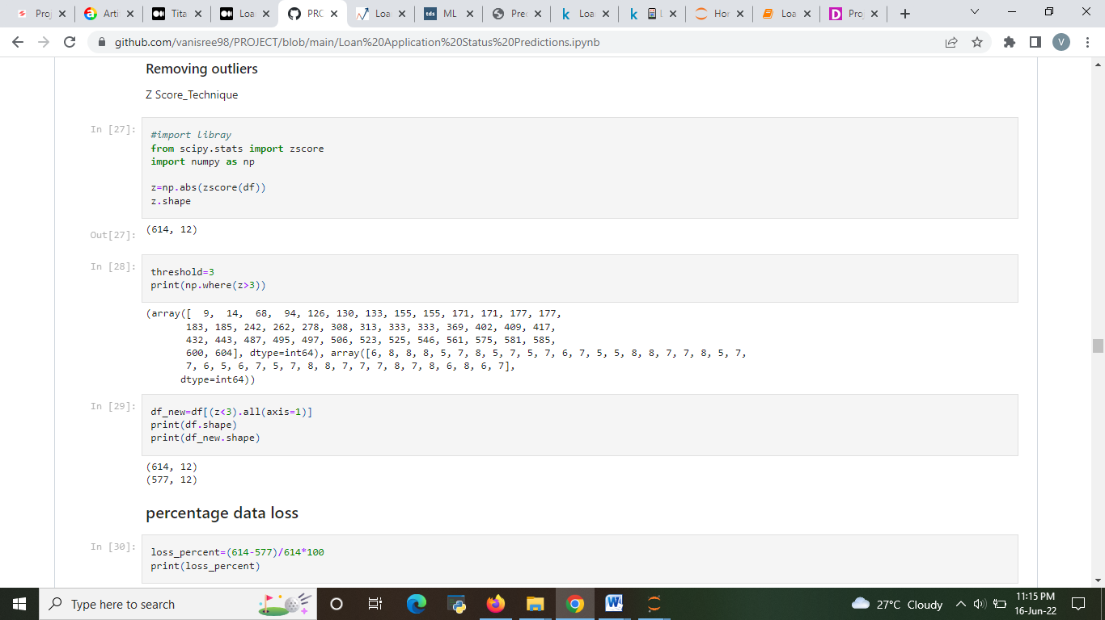

* Removing outlier using z score is 6 % data loss occurs

Now after preprocessing we need to perform encoding since we have a few categorical data such as Education, Gender, Married, Dependents, Self_Employed etc.

There are two encoding techniques present one is label encoding and other is one hot encoding.

* Label encoding needs to be done only with the labeled data. This label encoding maps the variables with numbers.
* One hot encoding creates multiple attributes and uses 0 and 1 to represent the data. We can perform this technique for the our data set.

And we also need to separate the dependent and independent variable. In this case our Y variable is loan status.

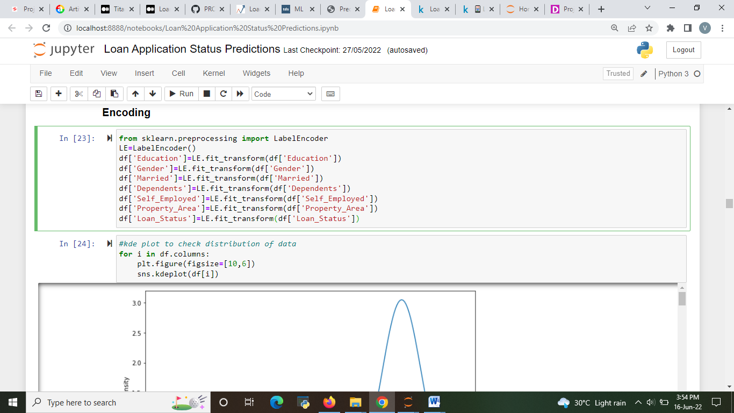

Fig 11: Label encoding.

We need to split the test and train data before proceeding further.

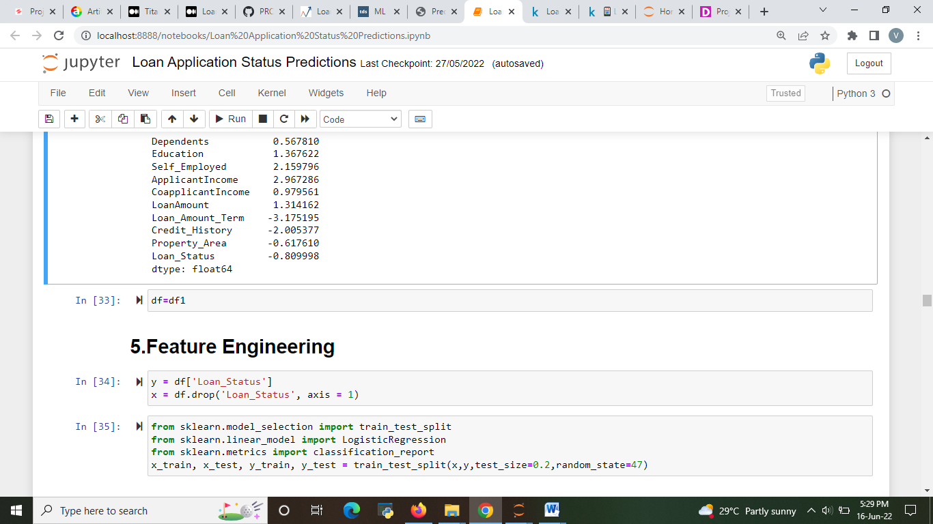 Fig 12 test train split

Another important preprocessing step is there which we have not seen in the previous example which is treating Data Imbalance which means sometimes data which we are provided with might not be balanced eg., in this case we have data about people got selected and rejected. Since the data will be in the form of most people got rejected and only few got selected our model will be imbalance and predict only the rejected people and fail to predict the selected people. So there is technique to treat the imbalanced data. Which is over sampling and under sampling. Over sampling means making the least data equaling to the highest data. Under sampling means reducing the highest count data to the lowest count data. Here in this case we are going to use over sampling.

Note : This procedure is done only for the classification problem.

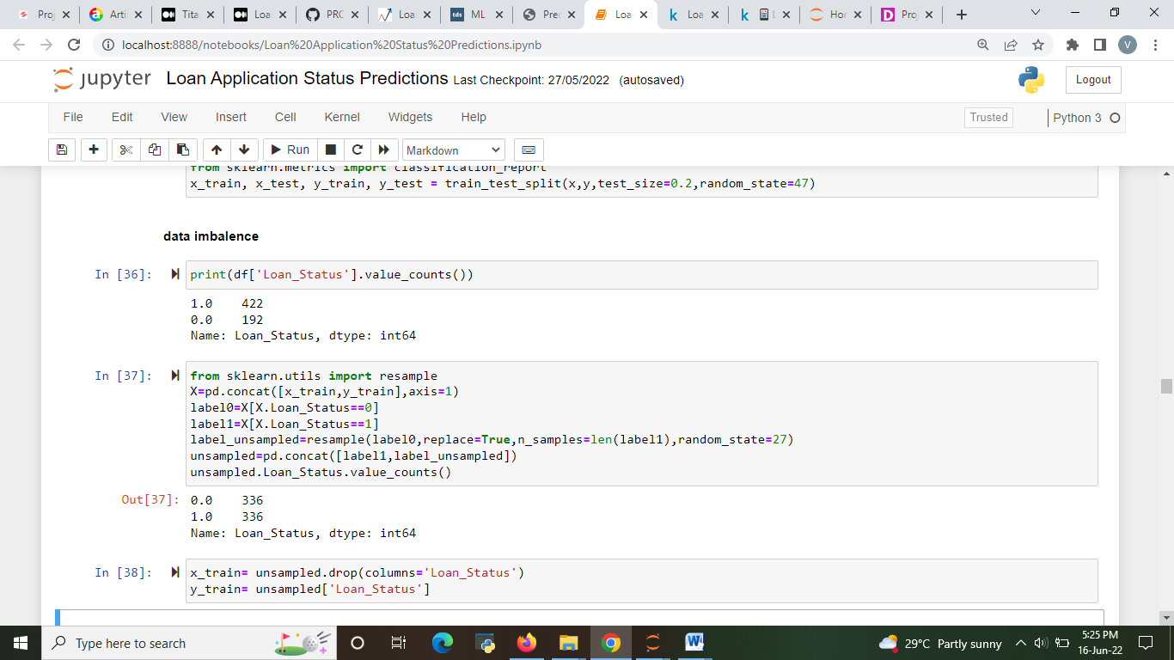

Fig 13 Data Imbalance

After encoding we need to perform scaling. Scaling needs to be done because attributes in our data might have a high range. we need to reduce that range in-order to perform efficient model. Here we used min max scaling we can also perform standard scaler to scale the data. After scaling your data will be converted into 0 to 1 format.

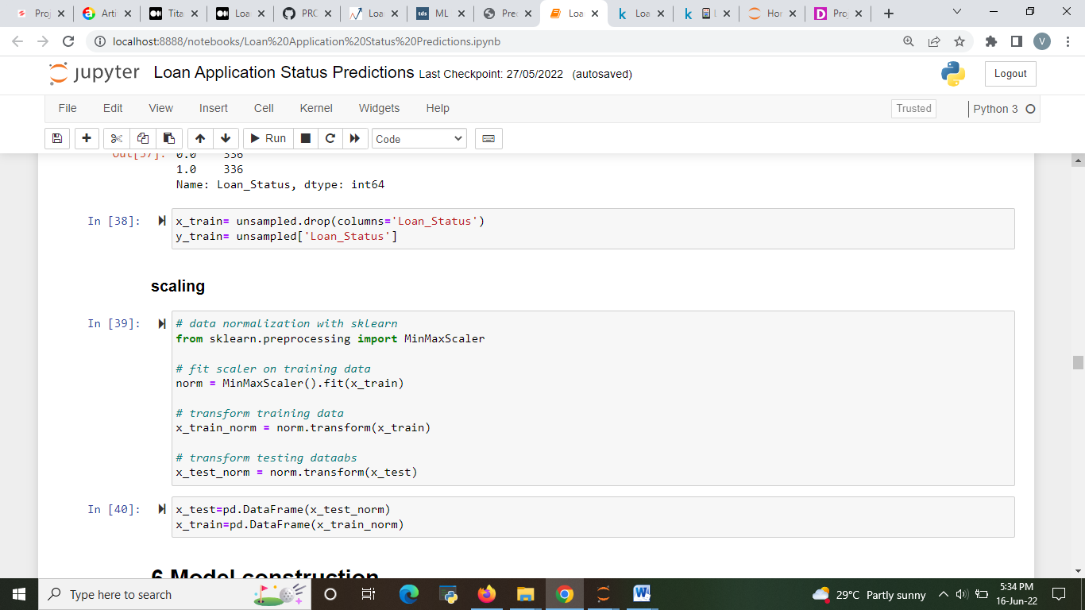

Fig 14: encoding

**Step 5- Building Machine Learning Models**

Now we have came to the most important and sensitive step of the whole analysis part which is constructing and finding best model for our data.

Now we need to construct various algorithms for this data set. Then using evaluation metrics, we need to finalize some best model for our problem. There are various algorithms available for classification problem we are going to see some of that.

We also need to find the cross-validation score to choose the best model

1. **Random Forest Classifier**

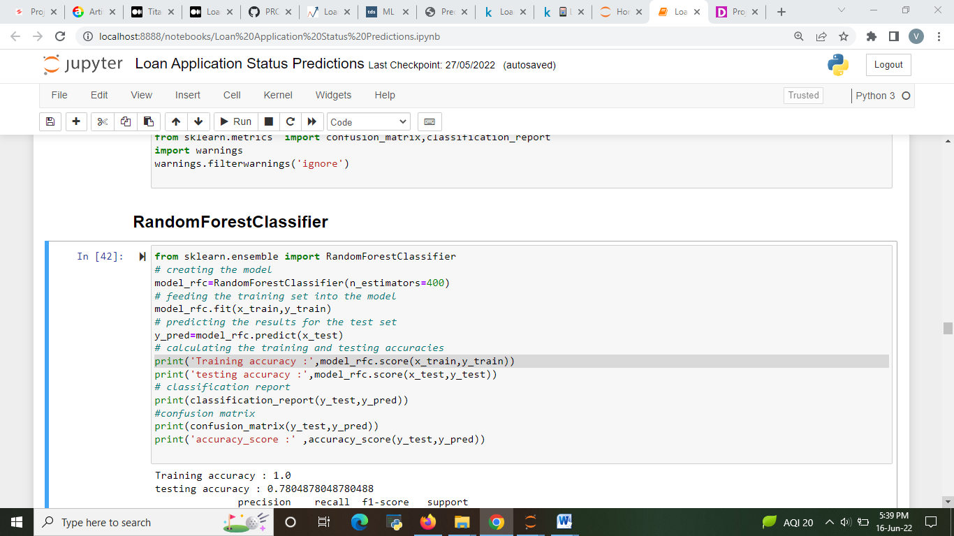

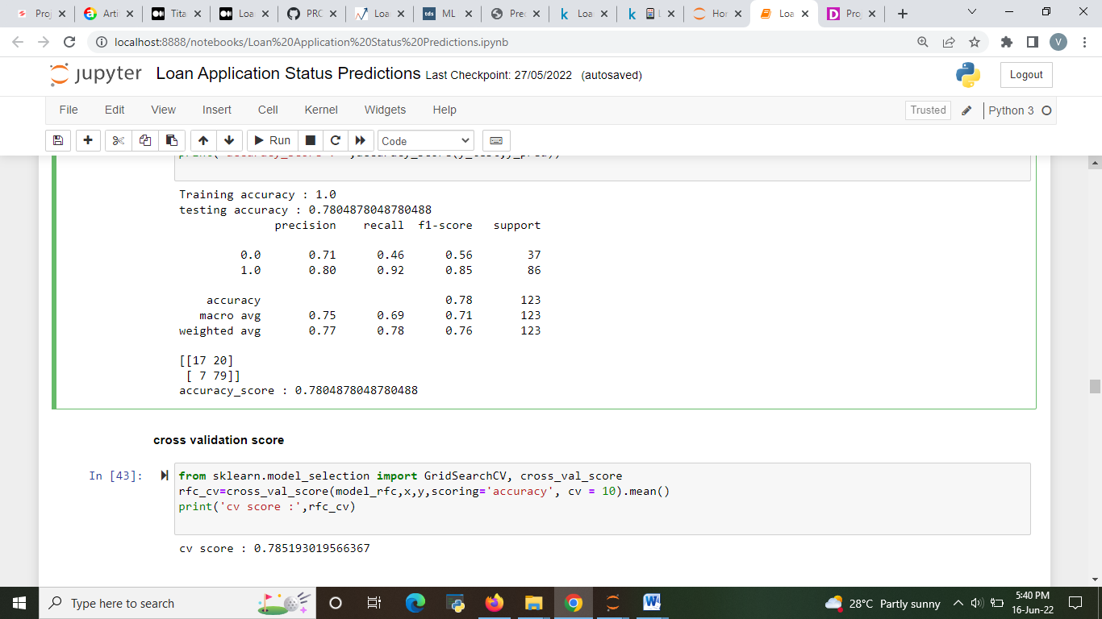

Fig 15: **Random Forest Classifier**

2. SVC

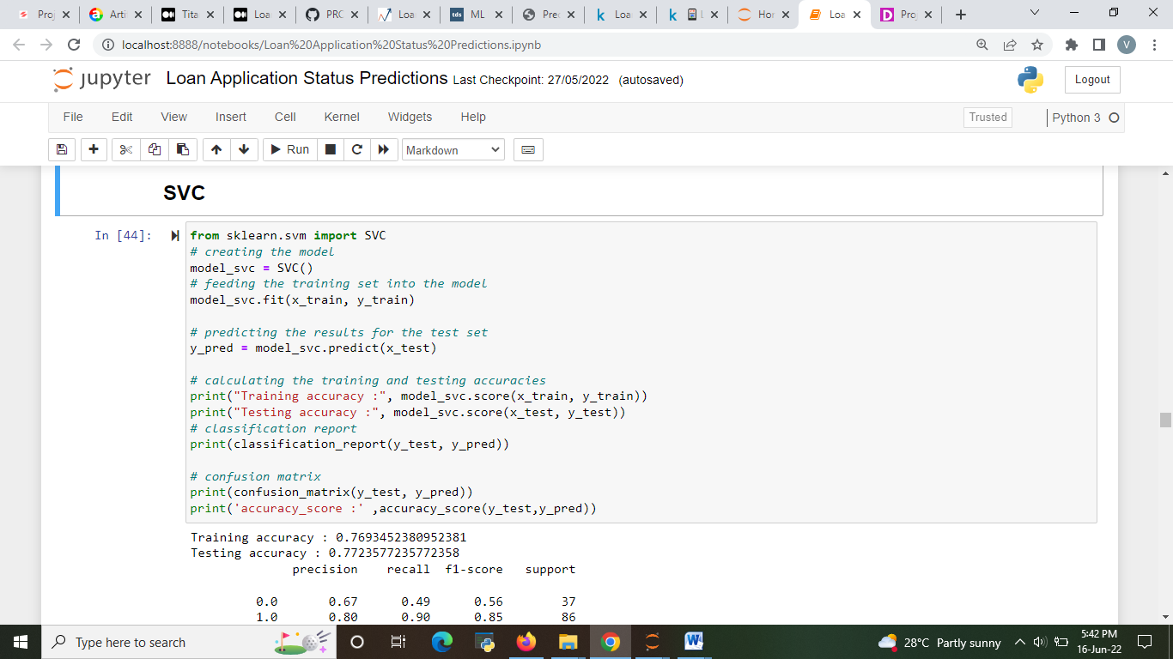

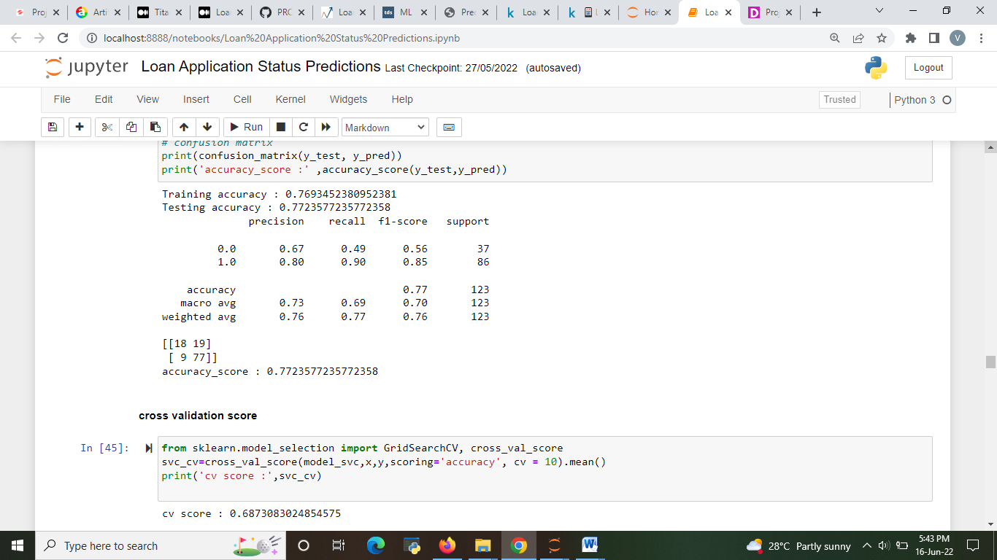

Fig 16: SVC

3. DECISION TREE CLASSIFIER

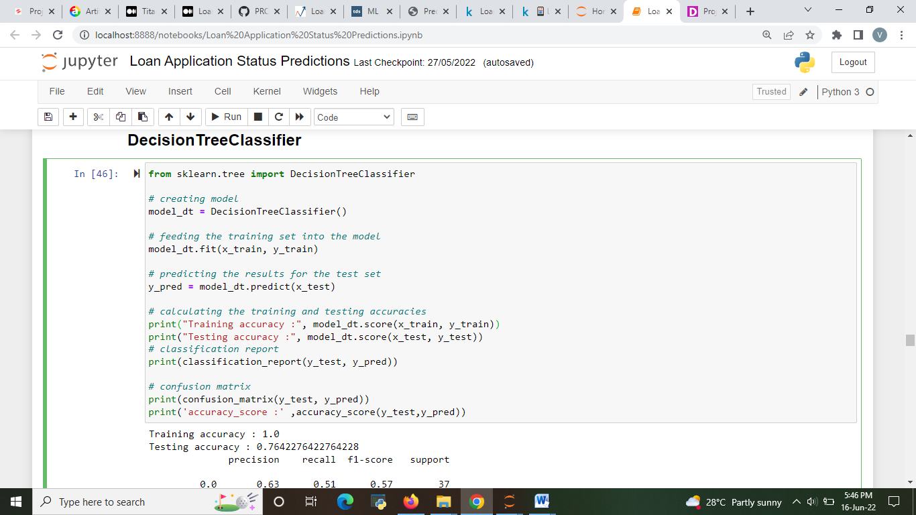

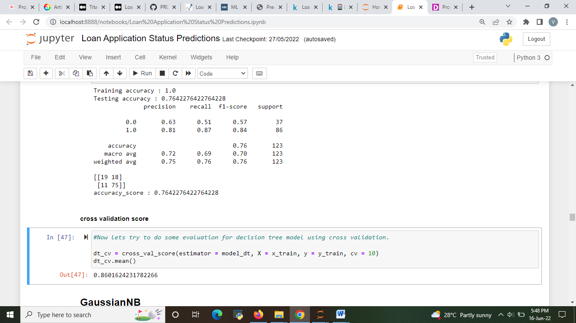

Fig 17: Decision tree classifier

4. **GaussianNB**

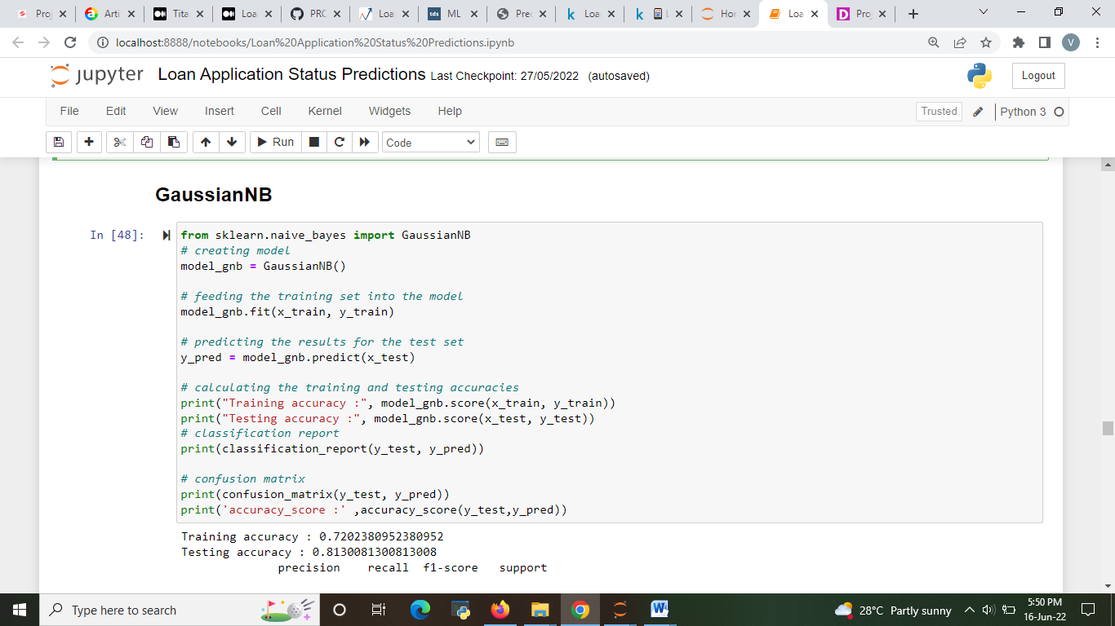

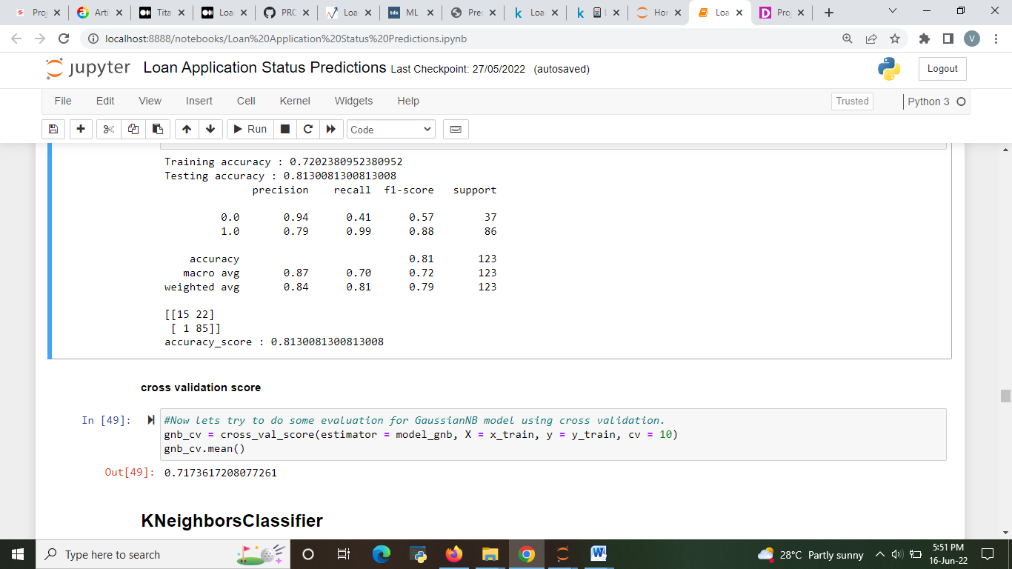

Fig 18: gaussian NB

5. KNN

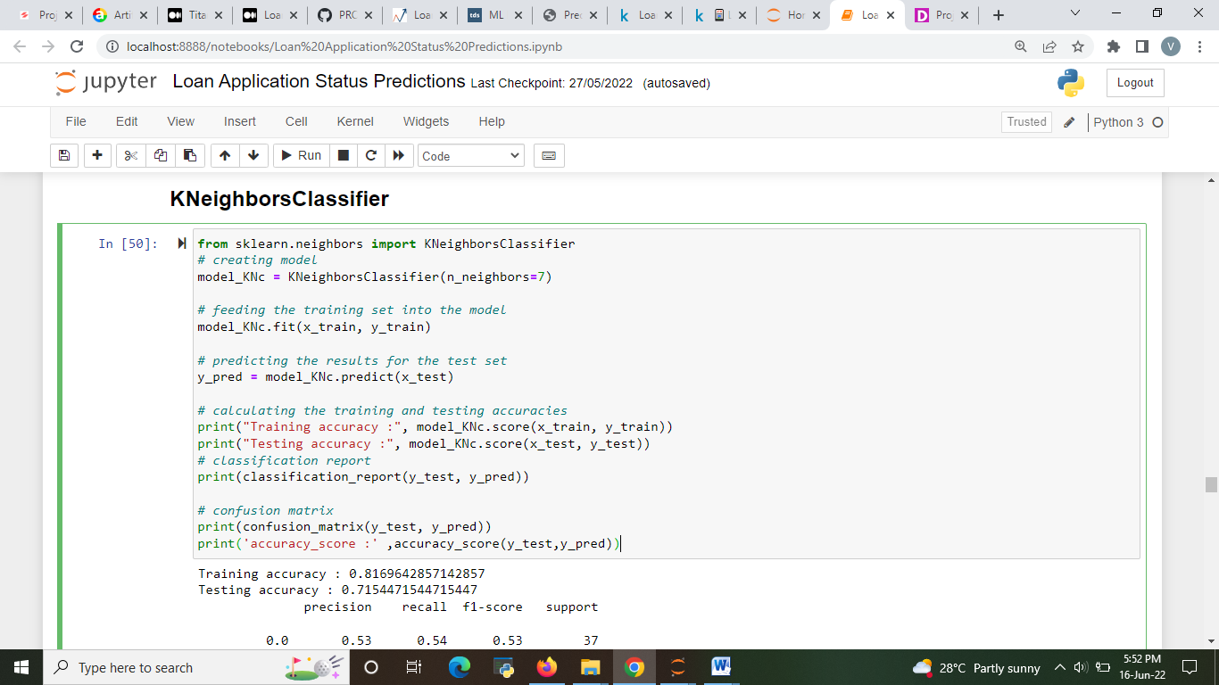

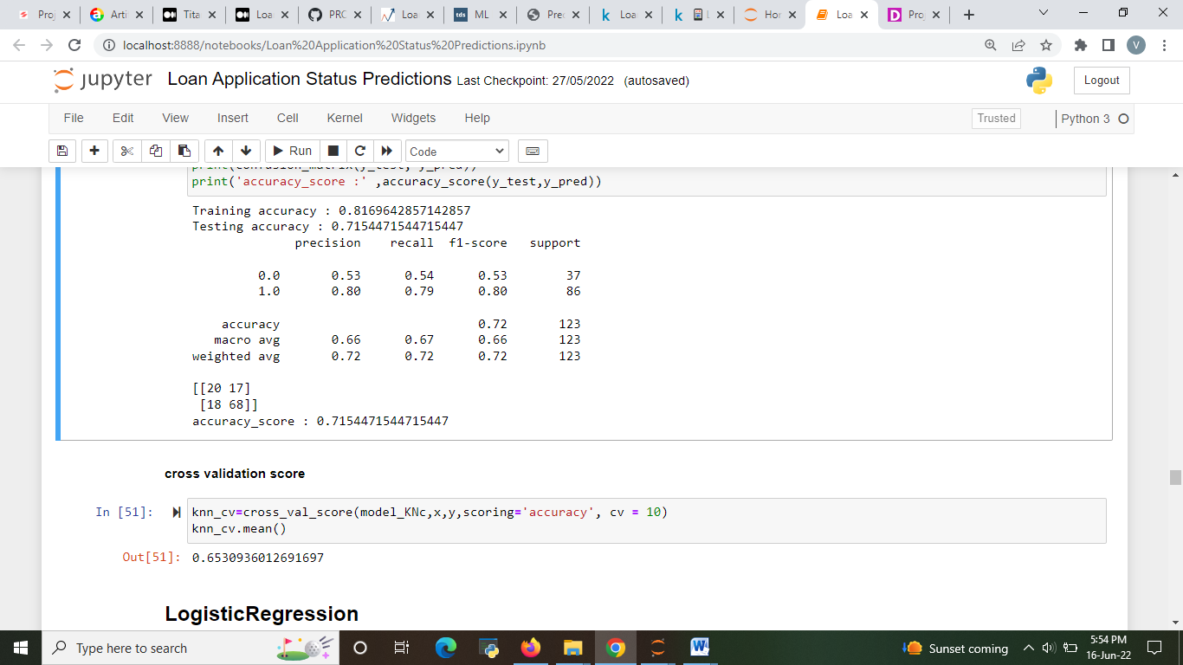

Fig 19. KNN

6. Logistic Regression

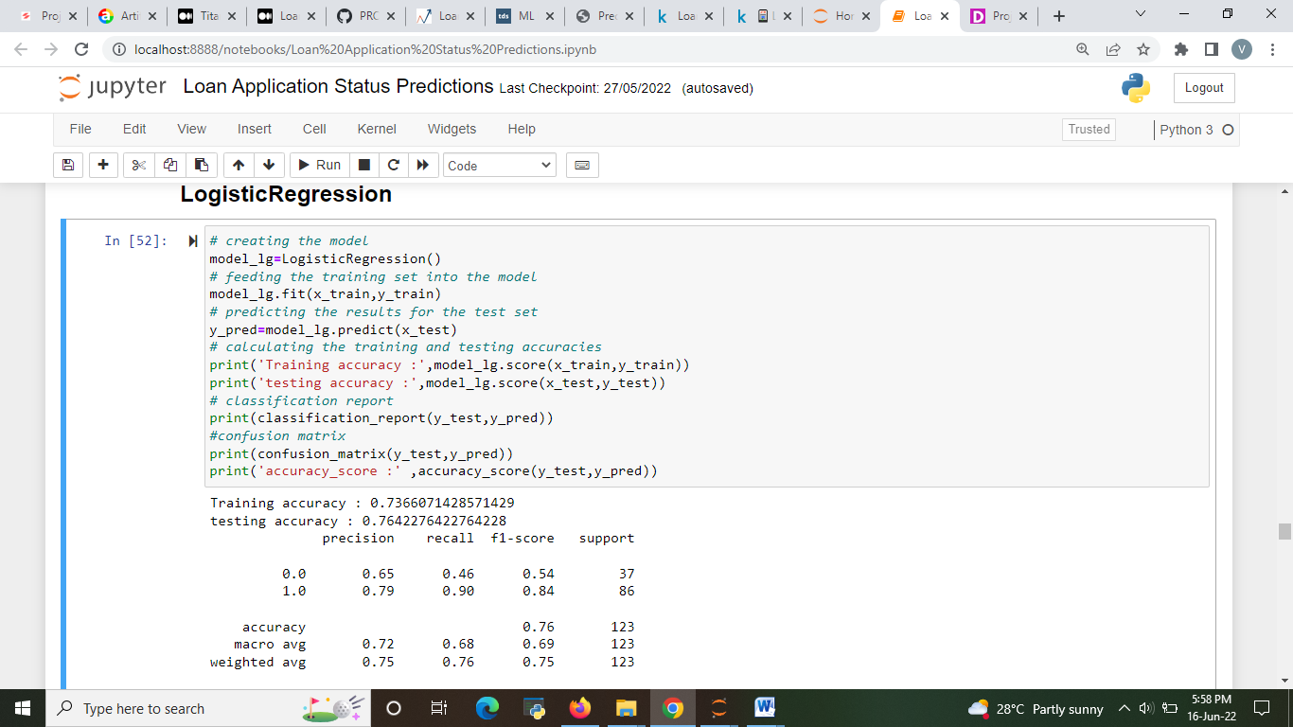  
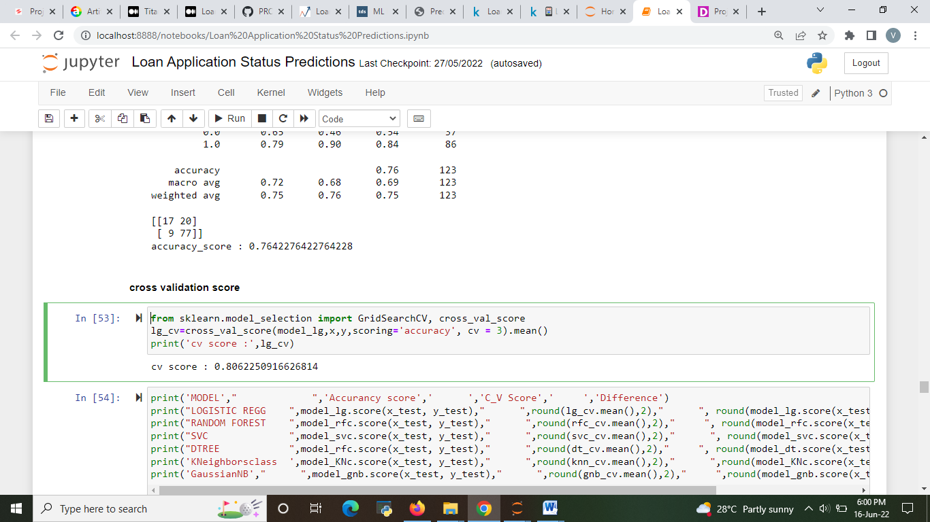

After constructing all the models, evaluation is done based on accuracy score and cv score

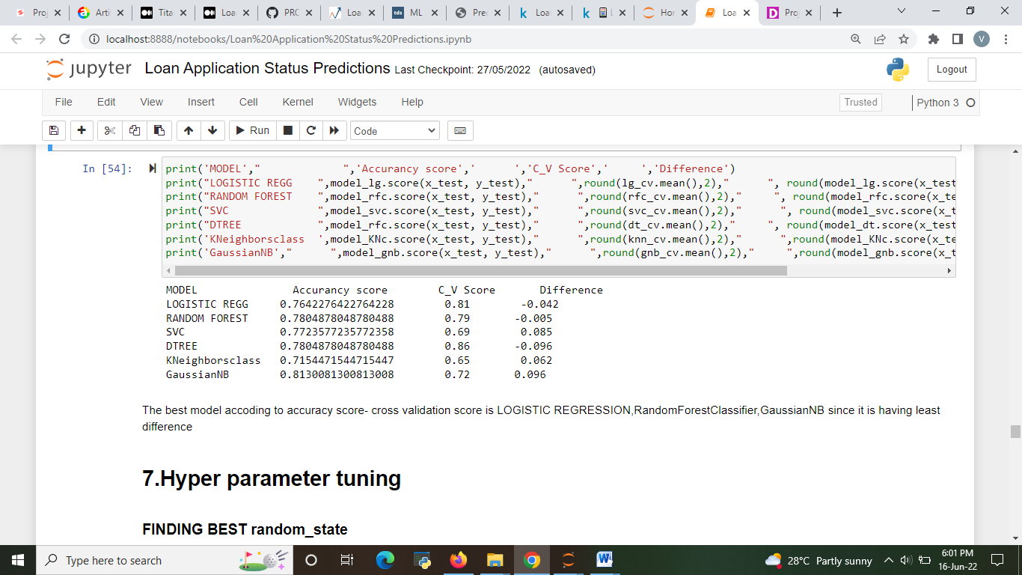

Fig 20 evaluating best model

the best model according to accuracy score and cv score chosen for hyper parameter tuning is random forest and svc so moving on with hyper parameter tuning with that model.

First before hyper parameter tuning the model we need to find the best random state. It helps in increasing the accuracy. Random state is the state where there is a least difference between test and train data score.

I have constructed a basic loop to find the best random state.

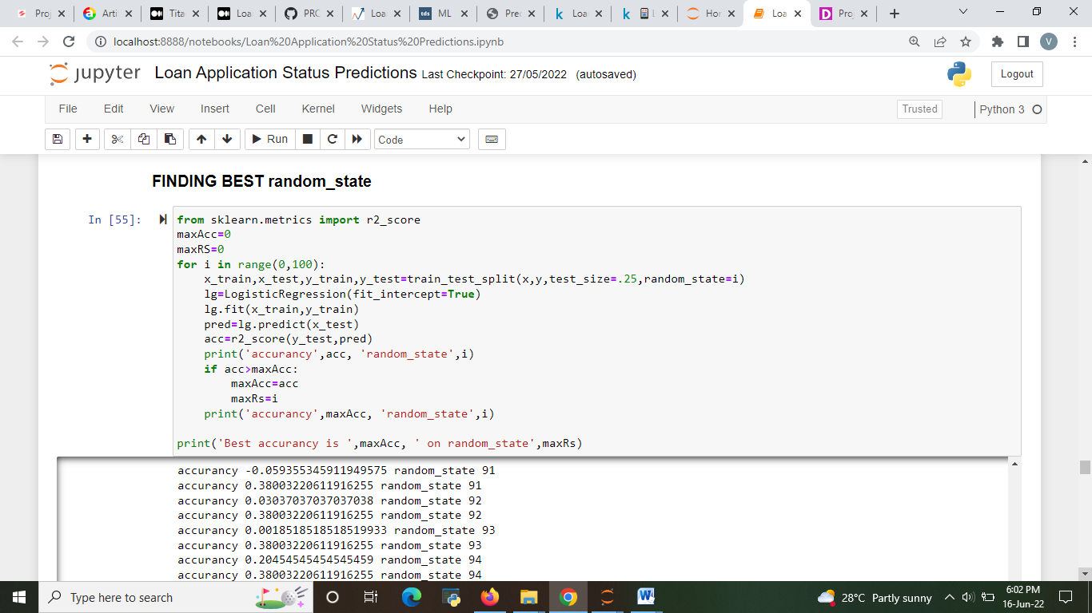

Fig 21: finding best random state.

After performing this model, we found the best random state is 63 in this case.

**Hyper parameter tuning** tends to increase the accuracy of the model. we are performing hyper parameter tuning for the best models.

The best model accoding to accuracy score- cross validation score is Logistic regression ,RandomForestClassifier ,GaussianNB since it is having least difference

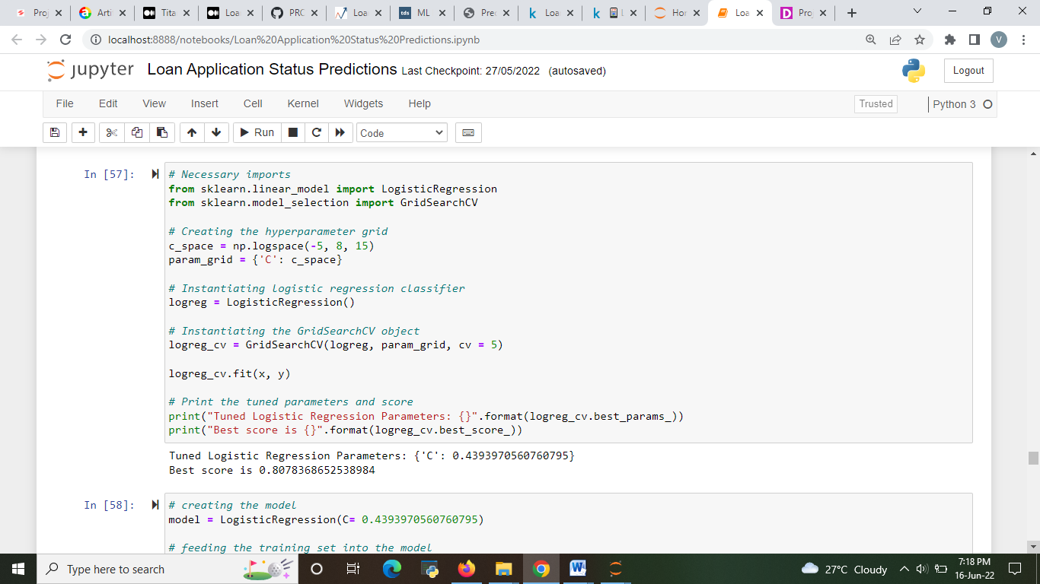

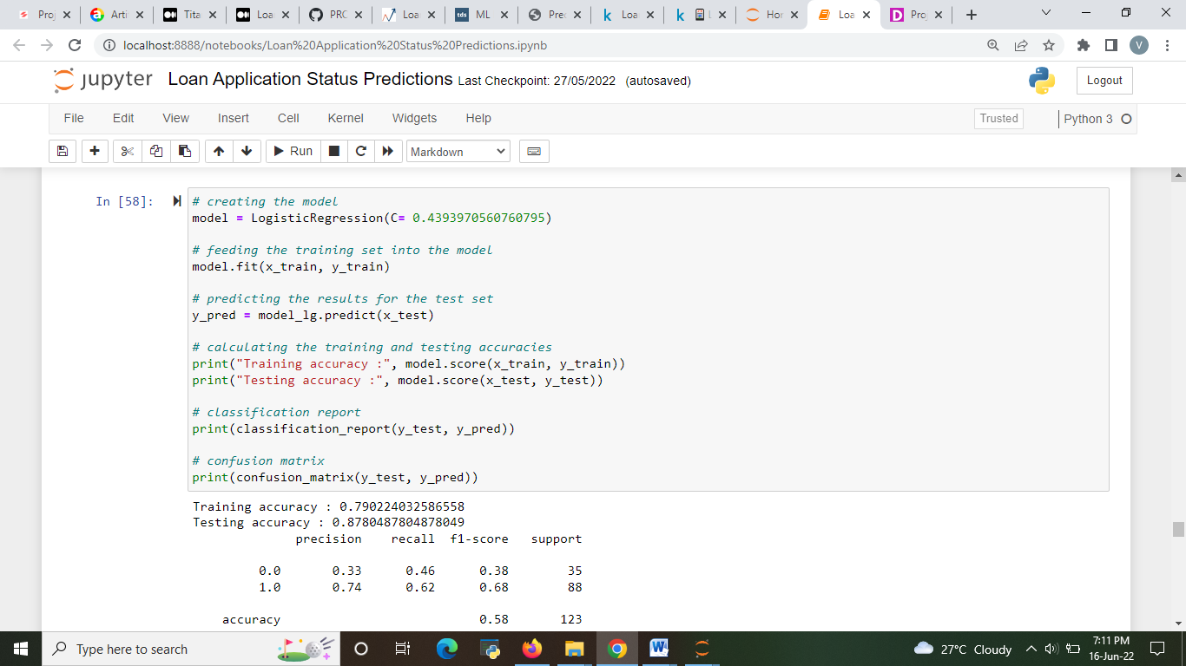

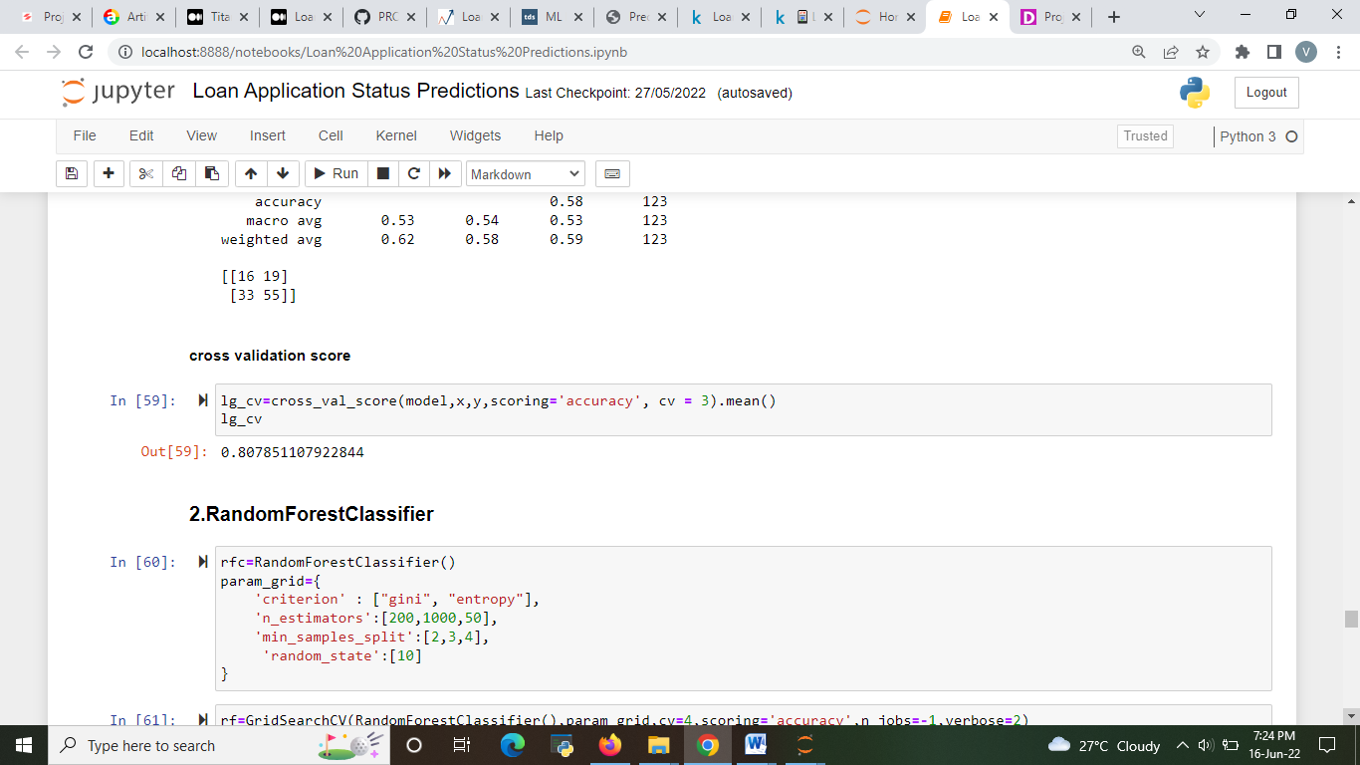

Fig 22 Hyper parameter tuning for Logistic regression.

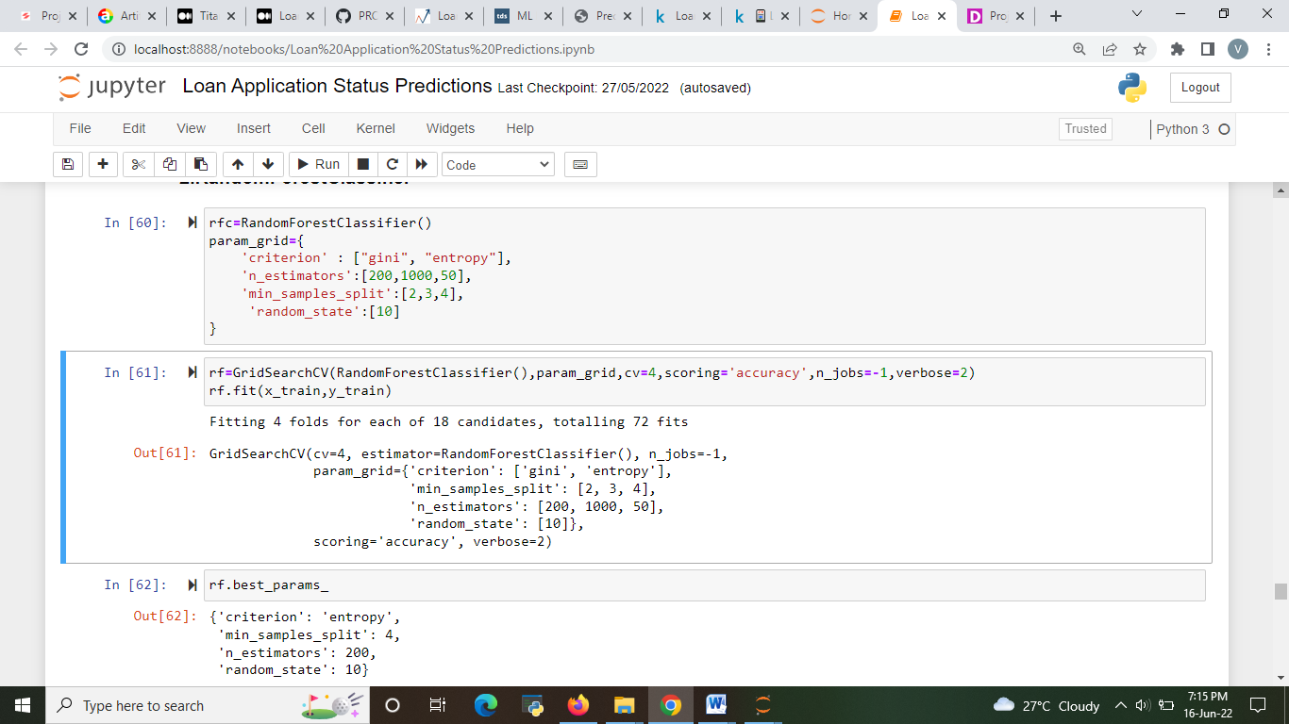

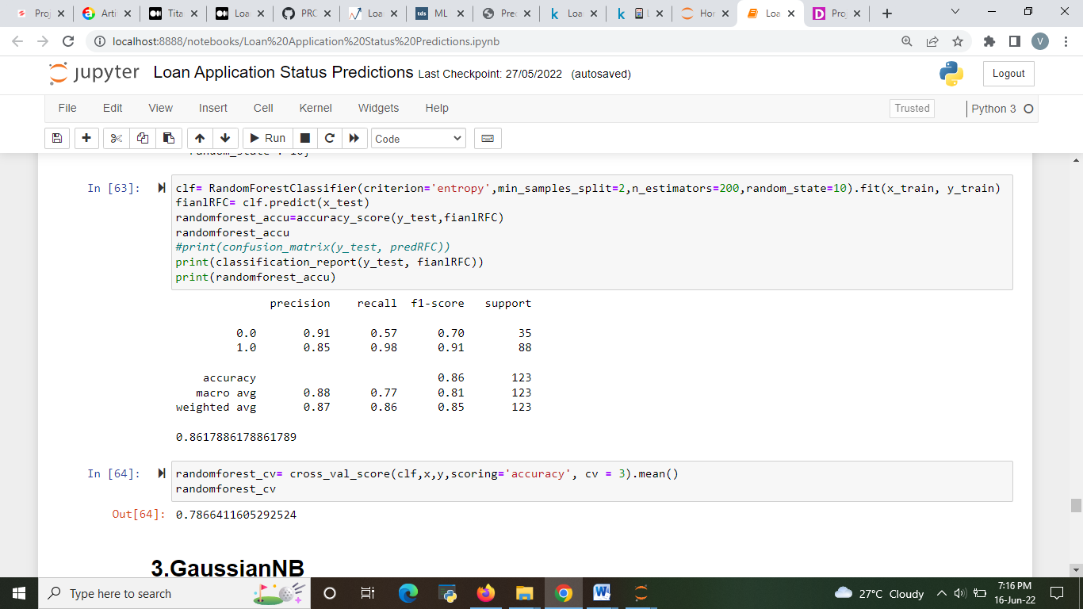

Fig 23 Hyper parameter tuning for RandomForest.

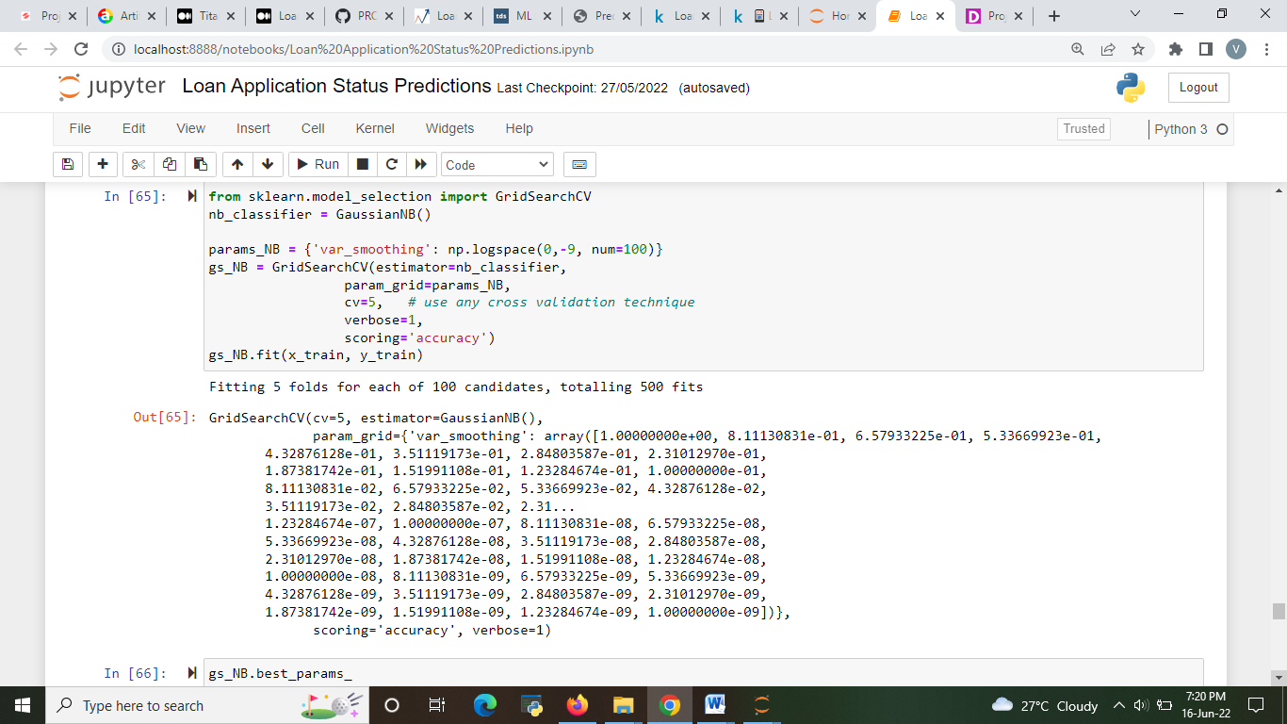

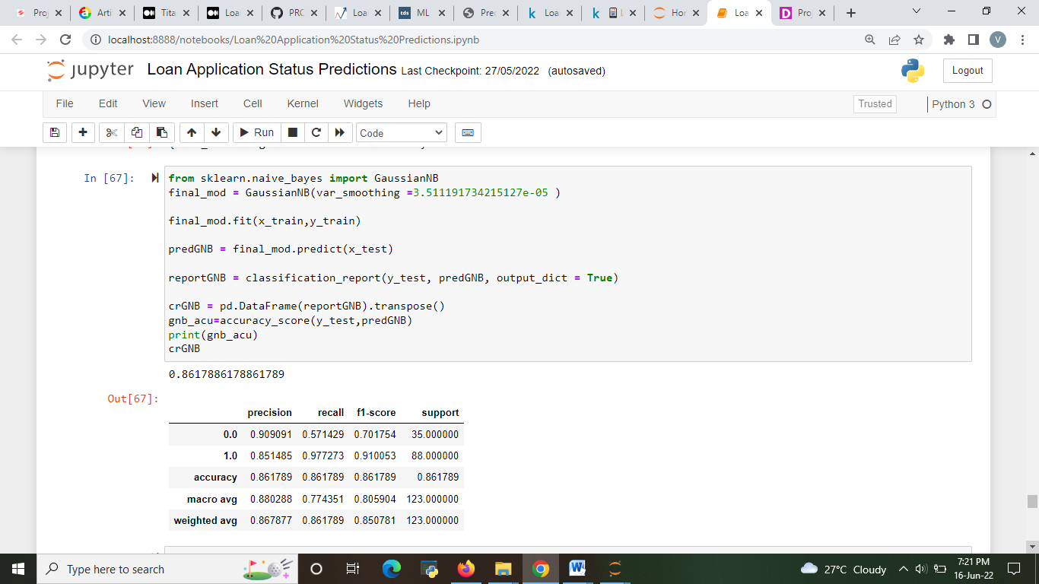

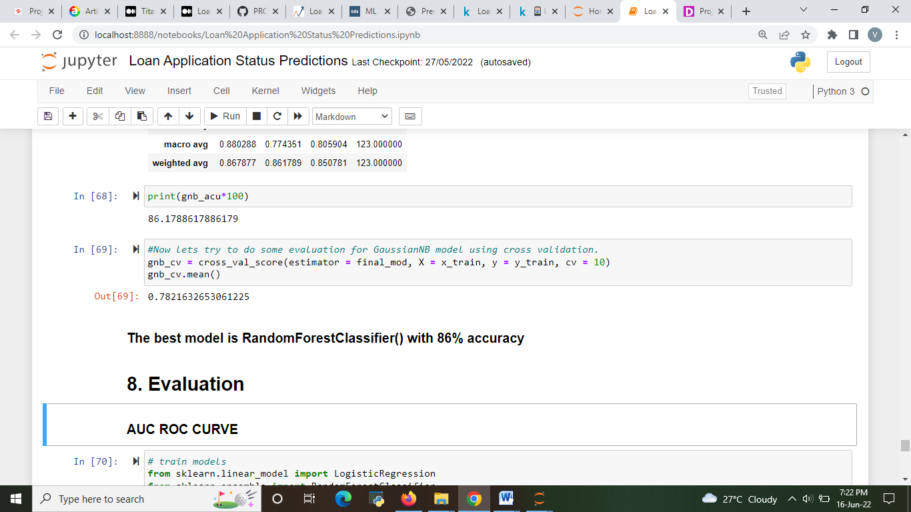

Fig 24 Hyper parameter tuning for GaussianNB.

**6.      CONCLUDING REMARKS**

There is evaluation metrics called as AUC and ROC curve

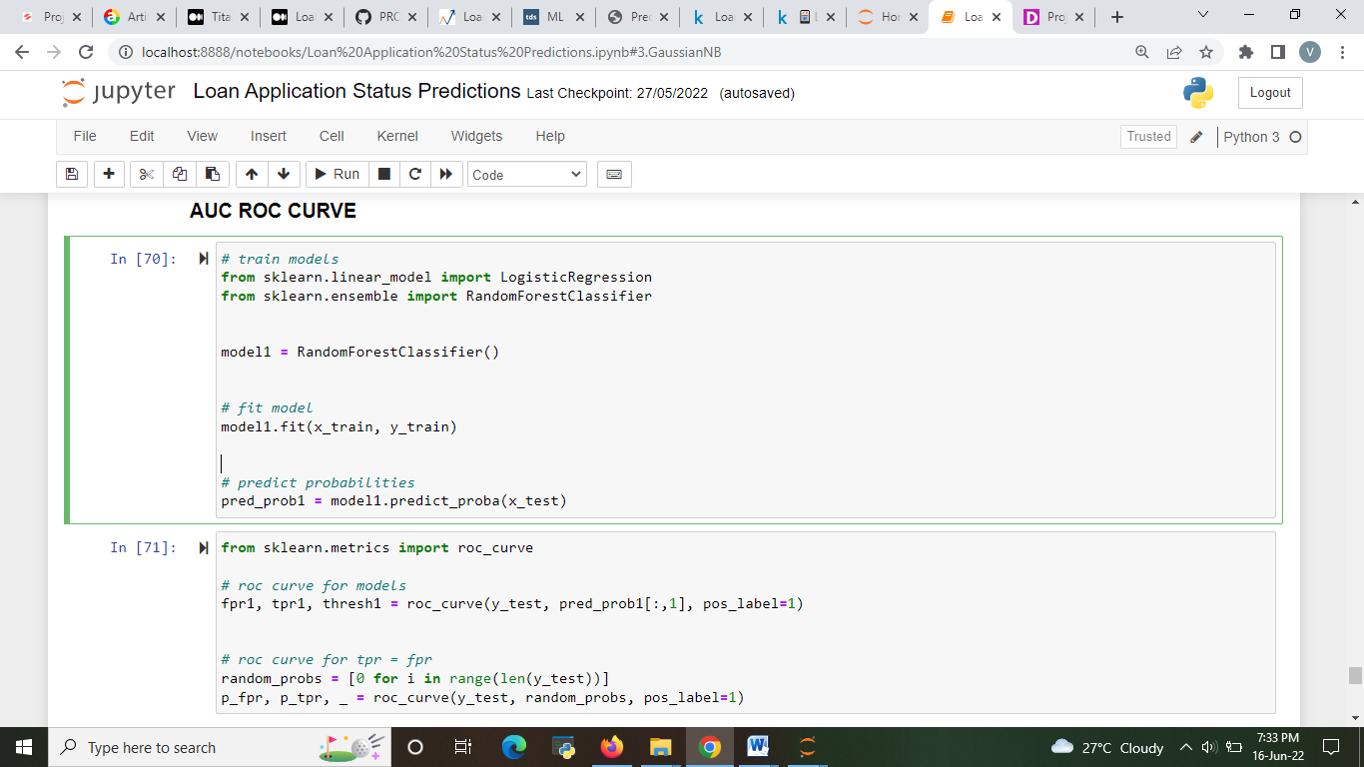

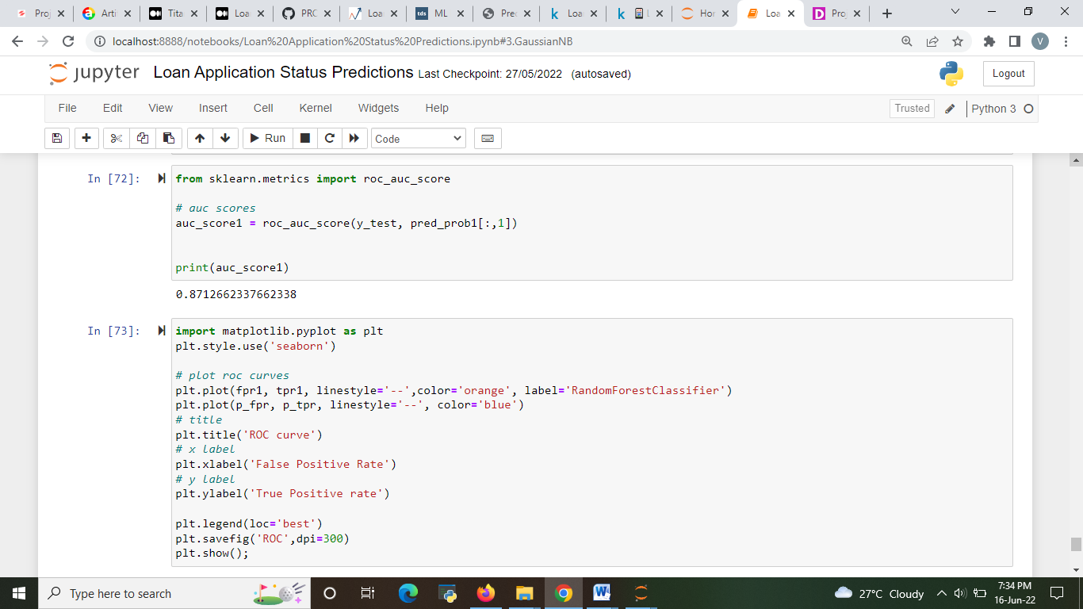

Fig 25 auc roc

Best model found after performing auc roc is “Random Forest classifier”

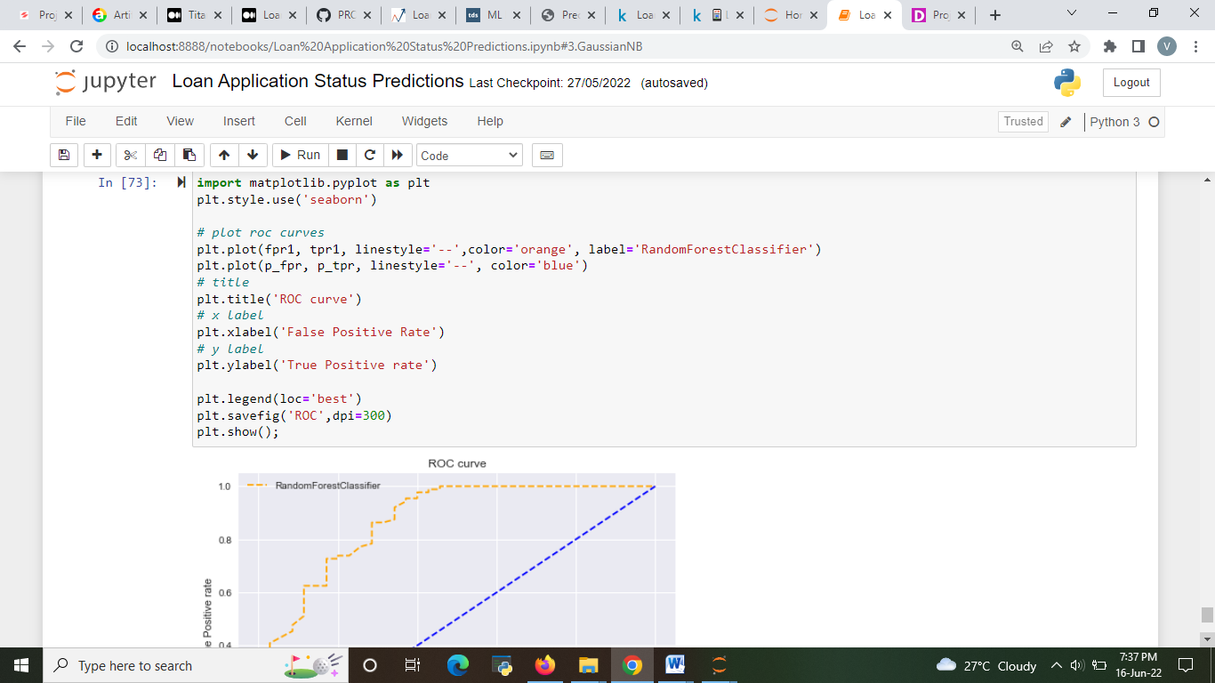

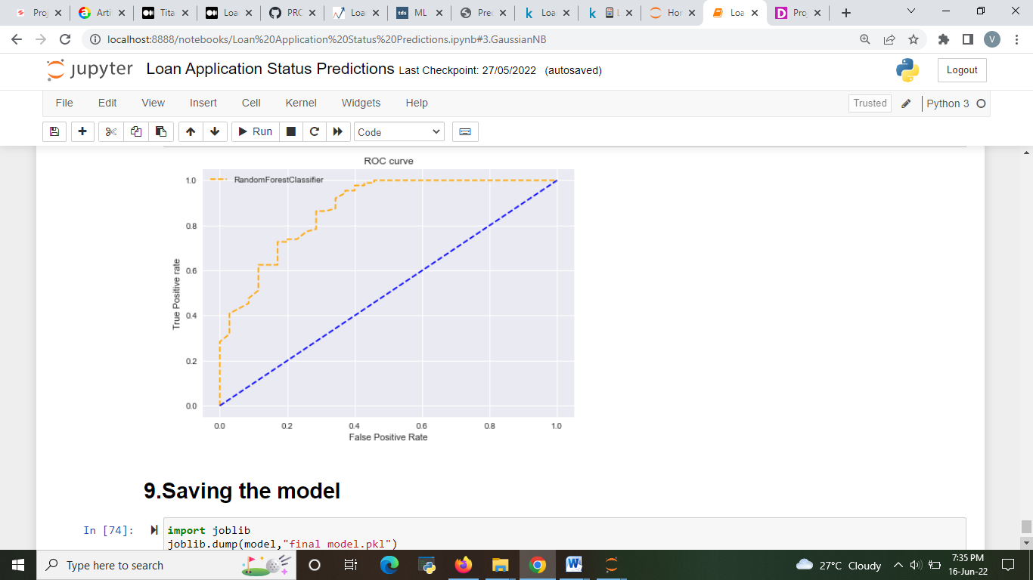

Fig 26: AUC ROC curve.

# Saving the model

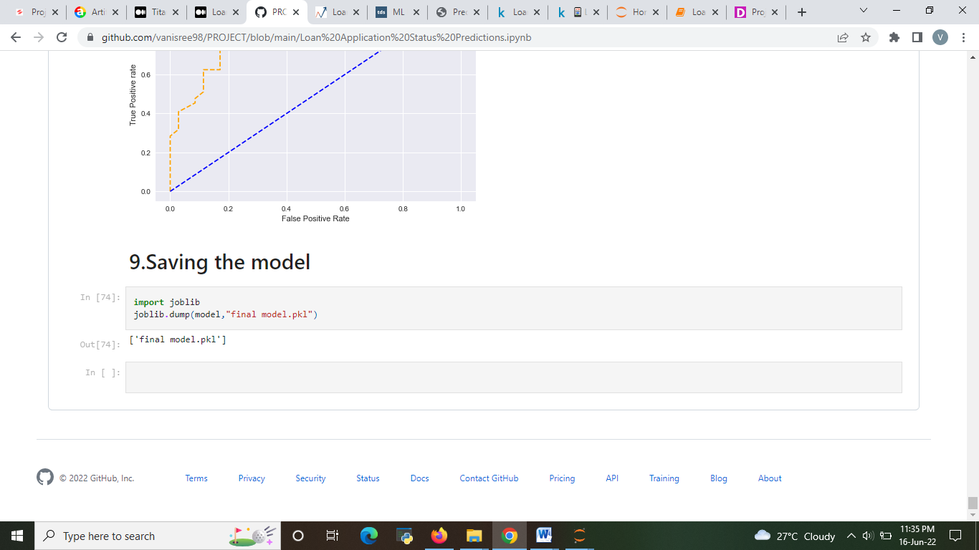

By the end of this project, we have predicted the our Target label which is “Loan Status”.

By performing this project, we got a good knowledge about how to perform an analysis and how important preprocessing a data. How to construct Machine learning models to predict the data. And how to choose the best model for specific data.

By performing uni-variant, bi-variant and multivariant analysis we can see the correlation between the data. We can make assumptions on the data and perform model.